Frameworx Standard

Information Framework (SID)

Metric Business Entities

Information Framework Suite
GB922 Metric
Release 19.0.1
October 2019

Latest Update: TM Forum Release 19.0.1 | TM Forum Approved  Suitable for Conformance
Version 19.0.1 | IPR Mode: RAND
NOTICE
This document and translations of it may be copied and furnished to others, and derivative works that comment on or otherwise explain it or assist in its implementation may be prepared, copied, published, and distributed, in whole or in part, without restriction of any kind, provided that the above copyright notice and this section are included on all such copies and derivative works. However, this document itself may not be modified in any way, including by removing the copyright notice or references to TM FORUM, except as needed for the purpose of developing any document or deliverable produced by a TM FORUM Collaboration Project Team (in which case the rules applicable to copyrights, as set forth in the TM FORUM IPR Policy, must be followed) or as required to translate it into languages other than English.

The limited permissions granted above are perpetual and will not be revoked by TM FORUM or its successors or assigns.

This document and the information contained herein is provided on an "AS IS" basis and TM FORUM DISCLAIMS ALL WARRANTIES, EXPRESS OR IMPLIED, INCLUDING BUT NOT LIMITED TO ANY WARRANTY THAT THE USE OF THE INFORMATION HEREIN WILL NOT INFRINGE ANY OWNERSHIP RIGHTS OR ANY IMPLIED WARRANTIES OF MERCHANTABILITY OR FITNESS FOR A PARTICULAR PURPOSE.

TM FORUM invites any TM FORUM Member or any other party that believes it has patent claims that would necessarily be infringed by implementations of this TM Forum Standards Final Deliverable, to notify the TM FORUM Team Administrator and provide an indication of its willingness to grant patent licenses to such patent claims in a manner consistent with the IPR Mode of the TM FORUM Collaboration Project Team that produced this deliverable.

The TM FORUM invites any party to contact the TM FORUM Team Administrator if it is aware of a claim of ownership of any patent claims that would necessarily be infringed by implementations of this TM FORUM Standards Final Deliverable by a patent holder that is not willing to provide a license to such patent claims in a manner consistent with the IPR Mode of the TM FORUM Collaboration Project Team that produced this TM FORUM Standards Final Deliverable. TM FORUM may include such claims on its website but disclaims any obligation to do so.

TM FORUM takes no position regarding the validity or scope of any intellectual property or other rights that might be claimed to pertain to the implementation or use of the technology described in this TM FORUM Standards Final Deliverable or the extent to which any license under such rights might or might not be available; neither does it represent that it has made any effort to identify any such rights. Information on TM FORUM's procedures with respect to rights in any document or deliverable produced by a TM FORUM Collaboration Project Team can be found on the TM FORUM website. Copies of claims of rights made available for publication and any assurances of licenses to be made available, or the result of an attempt made to obtain a general license or permission for the use of such proprietary rights by implementers or users of this TM FORUM Standards Final Deliverable, can be obtained from the TM FORUM Team Administrator. TM FORUM makes no representation that any information or list of intellectual property rights will at any time be complete, or that any claims in such list are, in fact, Essential Claims.
Direct inquiries to the TM Forum office:

4 Century Drive. Suite 100
Parsippany, NJ 07054 USA
Tel No. +1 973 944 5100
Fax No. +1 973 998 7916
TM Forum Web Page: www.TM Forum.org

Table of Contents
Table of Contents 4
List of Figures 5
List of Tables 7
Metric ABE 8
1.1 Metric example introduction 9
1.2 Metric Definition ABE 10
1.3 Metric ABE 52
Best Practices 61
1.4 Generic Best Practices 61
1.5 Use Case-Specific Best Practices 61
1.5.1 Case 1 – TM Forum GB935 Business Metrics 61
1.6 Resource Performance Management Metrics 68
Characterization of Existing Metrics Models 71
1.7 Overview of OMG SMM 71
1.8 Overview of OSI Systems Management Metric Objects 74
1.9 Overview of the NIST Cloud Computing Metrics 76
1.10 Comparison of the Metric Models 81
1.11 Correspondence between OMG SMM, NIST, and TM-Forum Metrics Models 83
Administrative Appendix 85
1.12 Document History 85
1.12.1 Version History 85
1.12.2 Release History 86
1.13 Company Contact Details 87
1.14 Acknowledgments 87

List of Figures

Figure Me.01 – Basic Metric Definition Entities…………………………………………………………………………11
Figure Me.01-Ex.01 – MetricDefinition and MetDefBusinessValue……………………………………………12
Figure Me.01-Ex.02 – MetricDefinition and MetricDefinitionCategory……………………………………….13
Figure Me.01a – Metric Definition and Specifications………………………………………………………………..15
Figure Me.02 – Metric Definition Measure………………………………………………………………………………..17
Figure Me.02-Ex.01 – MetricDefMeasure and MetricDefinitionDeterminationMethod……………..18
Figure Me.03 – Metric Definition Description and Dimension……………………………………………………20
Figure Me.04 – Metric Definition Hierarchy……………………………………………………………………………….21
Figure Me.04-Ex.01 – MetricDefinitionHierarchy……………………………………………………………………….22
Figure Me.05 – Metric Definition Involvement…………………………………………………………………………..23
Figure Me.05-Ex.01 – MetricDefinitionInvolvement……………………………………………………………………24
Figure Me.06 – Metric Definition Using Characteristics……………………………………………………………..26
Figure Me.07a - Metric Threshold Definition - Derived Associations………………………………………….28
Figure Me.07b - Metric Definition Threshold Associations…………………………………………………………30
Figure Me.07c – Metric Indicator – Threshold…………………………………………………………………………….31
Figure Me.08 – Metric Definition Measure Threshold Rule………………………………………………………..32
Figure Me.07-08-Ex.01 – Simple consequence…………………………………………………………………………..34
Figure Me.07-08-Ex.02 – Constraints on consequences……………………………………………………………..35
Figure Me.07-08-Ex.03 – Several consequences and re-use………………………………………………………..36
Figure Me.07-08-Ex.04 – MetricThresholdRuleDef tolerancePeriod, toleranceNumber……………..37
Figure Me.07-08-Ex.05 – Specific consequences for non-measurable………………………………………..38
Figure Me.07-08-Ex.06 – Example 2 of rules for a MetricDefMeasure………………………………………..39
Figure Me.07-08-Ex.07 – Example 2 of rules for a MetricDefMeasure- Alternative Solution……….40
Figure Me.09 – Metric Measure Notification definition………………………………………………………………42
Figure Me.10 – Metric Measure Definition Groups……………………………………………………………………44
Figure Me.11 – Metric Measurement Job………………………………………………………………………………….45
Figure Me.12 – Monitored Metric Object Criterion……………………………………………………………………47
Figure Me.13 – Metric Threshold Job and MetricDefMeasureThresholdSet……………………………….49
Figure Me.14 - Metric Applicabilty…………………………………………………………………………………………….50
Figure Me.15 - Metric Measure Definition Expression……………………………………………………………….51
Figure Me.16 –Basic MetricMeasureEntities………………………………………………………………………………53
Figure Me.17 – Metric Threshold………………………………………………………………………………………………55
Figure Me.17-Ex.01 – MetricMeasure and triggered consequence…………………………………………….56
Figure Me.17-Ex.02 –Consequence depends on previous rule……………………………………………………57
Figure Me.17-Ex.03 – Several consequences triggered for a MetricMeasure……………………………..58
Figure Me.17-Ex.04 – Consequence depends on previous rule………………………………………………….59
Figure Me.18 – Metric Observation……………………………………………………………………………………………60
Figure A-1 Core concepts of OMG Structured Metrics Metamodel……………………………………………71
Figure A-3 SMM Measure Relationships…………………………………………………………………………………….73
Figure A-3 SMM Measurement Relationships……………………………………………………………………………74
Figure A-4 Severity Indicating Gauge threshold examples………………………………………………………….75
Figure A-5 Inheritance structure of metric objects……………………………………………………………………..76
Figure A-6 NIST Metrics Model…………………………………………………………………………………………………..78
Figure A-7 Refinement of NIST Cloud Metrics model reflecting on-going work…………………………………..80
Figure A-8 Example of Use of Refined NIST metrics……………………………………………………………………81

List of Tables

Table A-1 Correspondences with OMG SMM metamodel 83

Metric ABE
One business dictionary defines metrics in terms of standards of measurement. They go on to define measurement in terms of values and units. Since there is a fundamental need to measure all aspects of enterprises based on Frameworx, the need for a Common Business Entity standardizing what a Metric is in Frameworx has been deemed as essential.
This addendum is organized in two parts—1) the standardized definition of the SID Metric ABE itself, including elaboration on the critical details of the definition, and 2) Best Practices for design and application of specific metrics, both generically and in specific application uses (e.g., Business Metrics, Performance Metrics, Revenue Assurance Metrics, Customer Metrics, Fraud Management Metrics, etc.). The Metric ABE is made up of a number of lower-level ABEs.
The next section describes the SID Metric ABE and its related components. This ABE was developed to support the SID principle of inherent extensibility by employing SID modeling patterns.
It’s in vision that other projects use and specialize the Metric ABE in some way (creating sub-classes and adding new entities) such as PM (Performance Management), RA (Revenue Assurance), SLA (Service Level Agreement), etc.
This guide book describes the Metric ABE in Common Business Entities Domain.
To find the Information framework figure, refer to “GB991 Core Frameworks Concepts and Principles” guide book.

Metric example introduction
All along this guide book, an example is used for illustrating the diagrams.
You will find illustrations after some diagrams using the well-known example of Layer 3 packet round-trip delay (also known as IP packet 2-way delay).
This metric is typically measured using the ping tool, which is based on ICMP echo (request and reply). It is a network-layer metric which impacts application-layer real-time and interactive services, such as voice, video, gaming, web surfing, etc. In turn, this low-level metric may be used in higher-level metrics, characterizing services (RFS and CFS), up to Customer Experience metrics.
The Entity measured by this metric is a pair of IP hosts (any two hosts: servers, end-user devices, routers, switches, fixed/mobile access nodes, gateways, etc.), or more precisely the IP path between them at the time of measurement.
There are many variants regarding the measurement process of this metric: active measurement relying on a ping-like tool which sends timestamped probe packets, or passive measurement, maybe by timestamping real traffic packets. Then there are different options concerning sampling (with or without a measurement session, packet size, packet payload, random or constant spacing of samples when applicable, etc.) and actual implementation of packet timestamping. Clock synchronization is not critical for two-way delay metrics, but it is for one-way delay metrics.
Further details about measurement methodology can be found for instance in TWAMP (Two-Way Active Measurement Protocol) RFCs from the IETF IPPM (IP Performance Metrics) Working Group (http://datatracker.ietf.org/wg/ippm/charter/).
There are similar tools in layer 2 (Ethernet OAM CFM LB (Loop Back: from IEEE 802.1ag or ITU-T Y.1730/1731), LSP ping, PW VCCV) and in layers 4-7 (various proprietary methods including service pings).

Metric Definition ABE
The core entity in the ABE is MetricDefinition. It provides basic facts that define or specify what a metric is, such as the name, description, and so forth. Any entity in the SID can be measured. The association between MetricDefinition and RootEntityType provides this capability. Instances of RootEntityType represent all the entities in the SID model. The *-* association between these two entities allows the same definition to be used to measure any number of entities in the SID model and for a SID entity to be measured by any number of definitions.
The definition of a metric can also be categorized, such as a business metric, a fraud metric, a revenue assurance metric. The association to MetricDefintionCategory allows many different categorizations of a MetricDefinition via the *-* association. The recursive association on MetricDefinition enables categories to be divided into sub-categories as needed, such as a revenue sub-category of a business metric or a profitability category of a business metric.
MetDefBusinessValue enables multiple relative business values to be associated to the MetricDefinition, such as revenue benefit, cost benefit, efficiency, customer experience, time to market, and so forth.

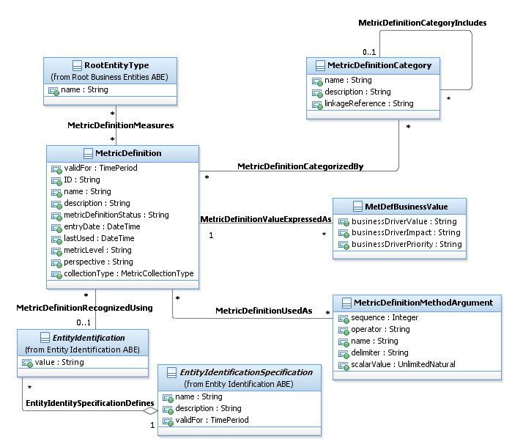
Figure Me.01 – Basic Metric Definition Entities

For the purpose of this example, some assumptions are made:
- Considering two IP hosts H1 and H2, the measurement system is able to initiate pings from H1.
- No measurement session is established between H1 and H2.
- H2 responds to H1 ping requests.
- The arbitrary sampling choice is to make 100 raw measurements at 1-second intervals, every 15 minutes.
- Multiple metrics of interest could be derived from the sample batches of 100 values: average, minimum, maximum, different percentiles, etc. Only the Average is illustrated here.
The following illustration explores the classes describing the metric: definition and business value.
The metricLevel optional attribute is set to 1 as an example. If metricLevel is used, the convention governing the numbering scheme should be included in the description (i.e., “low numbers mean high importance”, or vice-versa).
Attributes like metricDefinitionStatus and lastUsed are dynamically modified during the lifetime of the object, by other processes which generate attribute-changing events: modification of the metric definition, usage occurrence of the metric, etc.
Finally, the MetDefBusinessValue is a business-oriented complement to the technical-oriented MetricDefinition.

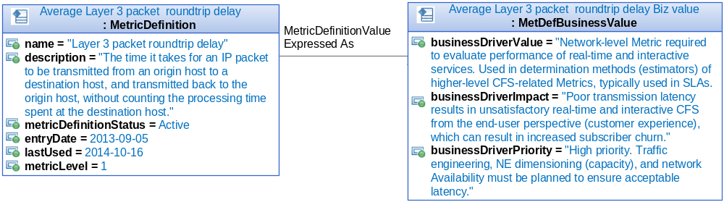
Figure Me.01-Ex.01 – MetricDefinition and MetDefBusinessValue

The following illustration shows examples of categories, as instances of MetricDefinitionCategory.
Two categories are represented:
- CFS-level performance,
- and Network-level performance, which covers both Resources and RFSes.
“Weekly % of Good Video Sessions for All Users” and “Estimated MOS of a video session” MetricDefinitions would fall within the former category, while “Layer 3 packet roundtrip delay” would fall within the latter.
The optional linkageReference attribute would refer to some other categorization approaches such as Frameworx domains or Business Architecture domains.
Relationships (possibly hierarchical) between MetricDefinitionCategory instances are possible using the MetricDefinitionCategoryIncludes association: in this example, CFSPerf would “include” NetworkPerf in the sense that CFSPerf metrics rely on NetworkPerf metrics.

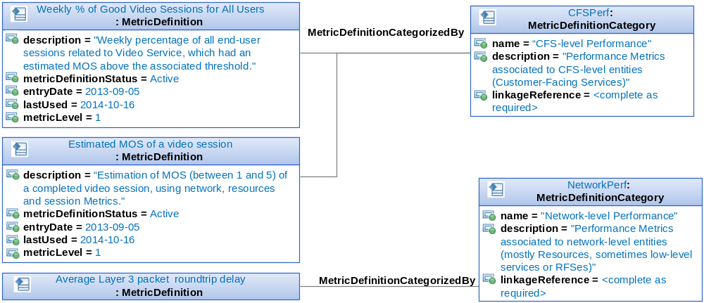
Figure Me.01-Ex.02 – MetricDefinition and MetricDefinitionCategory

MetricDefinition can be defined for any type of entity that a Metric measures (therefore the association to RootEntityType). The SID uses the EntitySpec/Entity pattern to dynamically instantiate entities. MetricDefinition is used to measure these dynamically defined entities.
Therefore, the association to Specification (as a base class to ResourceSpec and ServiceSpec) has been included as shown in Figure Me.01a – Metric Definition and Specifications.
There is also option to extend the model by associating MetricDefinition with other entity specifications.
Examples for ProductSpec and PerformanceSpec are shown. MetricDefinition has been sub-classed to explicitly show these two types of MetricDefintions. From an implementation perspective they can be rolled up into MetricDefintion if desired, or MetricDefinition could be rolled down into them. Often application boundaries dictate which of the two approaches to take.

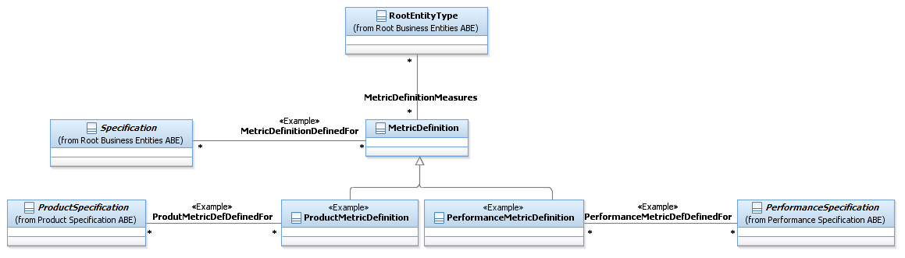
Figure Me.01a – Metric Definition and Specifications

Metrics may be calculated in a number of different ways from a simple ratio to a complex expression. Figure Me.02 – Metric Definition Measure shows the entities used to calculate a metric value.
A MetricDefMeasure specifies a measure of a specific aspect of an entity, such as lost packets or dealer sales target achievement.
A MetricDefinition may have many MetricDefMeasures. One example of many is that one measure may be in Fahrenheit and another may be in Centigrade.
Two entities, MetricDefinitionDeterminationMethod and MetricDefinitionMethodArgument support the requirement of different ways to calculate Metrics.
Basic facts about the method, such a type (ratio, sum, and so forth) are contained in the MetricDefinitionDeterminationMethod.
The arguments that represent the expression are contained in one or more MetricDefinitionMethodArgument. An argument may be the same or another MetricDefinition.
For example, a simple ratio of metric definition A divided by metric definition B would be represented by two instances of the arguments. The numerator would be related to metric definition A with a sequence of 1 and an operator of “/”. The denominator would be related to metric definition B with a sequence of 2.
The delimiter attribute, such as “(“and“)”, enables more complex expressions. For example (metric definition A + metric definition C).
When an expression is too complex to represent using the arguments, such as one that includes logic and using other entities) the derivationFormula attribute can contain a reference to logic (code) that performs the calculation.
Remark: An implementation of the model may choose to share same determination method for many metric definition measures. If this is the case then the association would be changed to *-*.

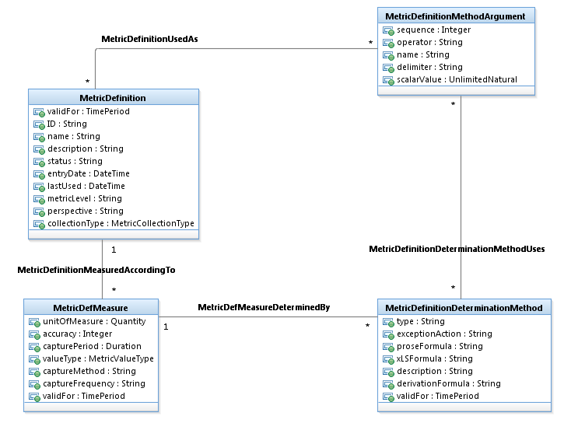
Figure Me.02 – Metric Definition Measure

The MetricDefMeasure is essentially a high-level description of the measurement method, while the details are provided in the MetricDefinitionDeterminationMethod.
In this example, the MetricDefinitionMethodArgument class is not used, since the raw sample values are not modeled as actual metrics, and thus have no MetricDefinition.

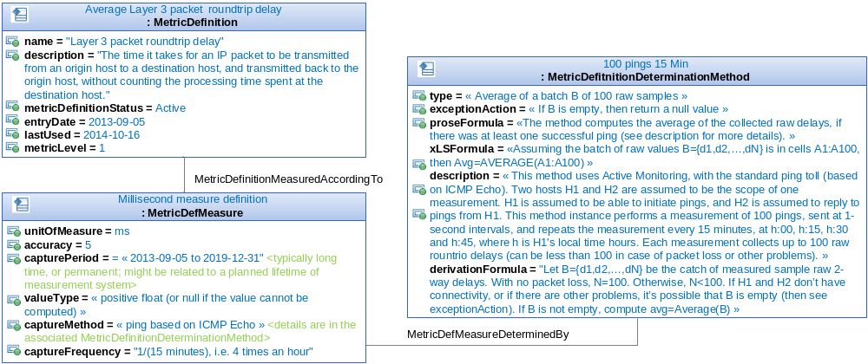
Figure Me.02-Ex.01 – MetricDefMeasure and MetricDefinitionDeterminationMethod

Figure Me.03 – Metric Definition Description shows how a MetricDefinition’s description can be extended as well as dimensional attributes that define a Metric.
The MetDefDescExtension entity enables additional descriptive text, such as references and owner notes, to be defined for a MetricDefinition. The metDefType attribute specifies the type of descriptive text contained in the descriptionExtension attribute.
The four-dimension related entities provide the ability to designate methods of organizing individual metrics into common sets, related by the value of the named dimension.
For example, a metric for revenue–individual instance values of revenue could be organized in the dimension of geography (Region 1 Revenues, Region 2 Revenues, etc.), or by Product (Wireless Revenue, Wire-line Revenue, Broadband Revenue, Advertising Revenue, etc.).
The characteristic term when describing dimension is “by”, as in “Revenue, by Product” or “Revenue, by Region”.
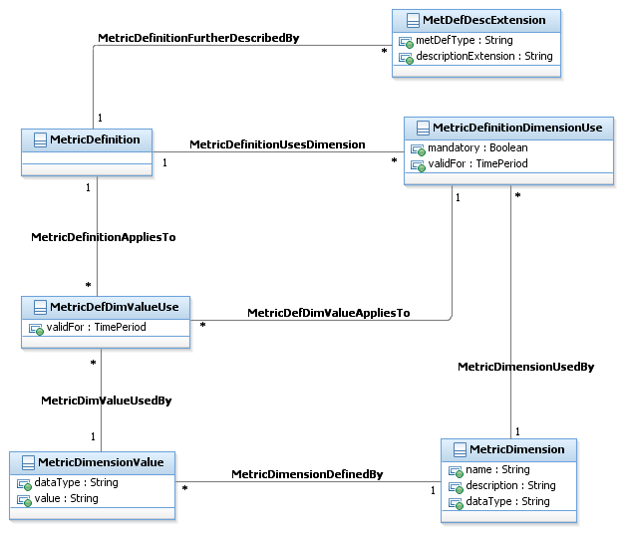
Figure Me.03 – Metric Definition Description and Dimension

Figure Me.04 – Metric Definition Hierarchy shows how hierarchies of metrics are represented.
MetricDefinitions can be related to one another in a variety of ways. One way is in a hierarchy of definitions, such as a calculation hierarchy.
MetricDefinitionHierarchy provides the ability to define any number of hierarchical relationships. MetricDefinitionHierarchyMember represents the relationship between two MetricDefinitions in a hierarchy, one playing the parent role and the other playing the role of a child.
For example, video sessions, with a synthetic scalar metric such as an estimated MOS (Mean Opinion Score), a number between 1 and 5; the per-session MOS KPI is computed using different low-level counters (packet loss, delay, delay variation, NE port-level frame counters, and so forth.
Another type of relationship could indicate one MetricDefinition has been replaced by another or could be used instead of another.

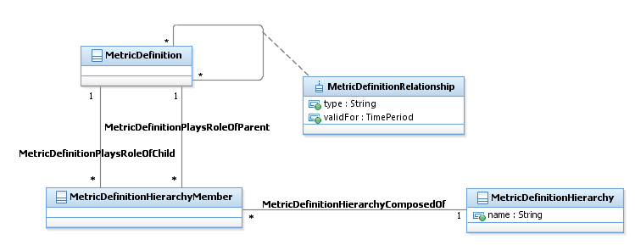
Figure Me.04 – Metric Definition Hierarchy

The following example illustrates two arbitrary metric organizations.
One of them is hierarchical, and represents a calculation hierarchy related to some performance model, represented here as an instance of MetricDefinitionHierarchy called SPPM.
Two other metrics are shown one for a MOS estimation of one video session for one end-user (M2), and another one for an overall synthesis of the performance of a Video Service offered by a Service Provider (M3). M3 is computed from M2, and M2 may involve M1-Avg (in its calculation.
M1-Avg, M2, and M3 are members of that SPPM hierarchy (as indicated by the corresponding instances of MetricDefinitionHierarchyMember), M3 as a parent only, M2 as both a parent and a child, and M1-Avg as a child only.
The other metric organization represents the connection between M1-Avg, M2, and M3 with respect to some service impact model. In this case, the service impact model might be a graph, without an implicit hierarchical tree structure. These relationships are modeled using the MetricDefinitionRelationship construct (associative class). If the service impact model of this example had also been hierarchical, then another instance of MetricDefinitionHierarchy (maybe called SIMM for Service Impact Metric Model) could have been used, with additional instances of MetricDefinitionHierarchyMember for M1-Avg, M2, and M3

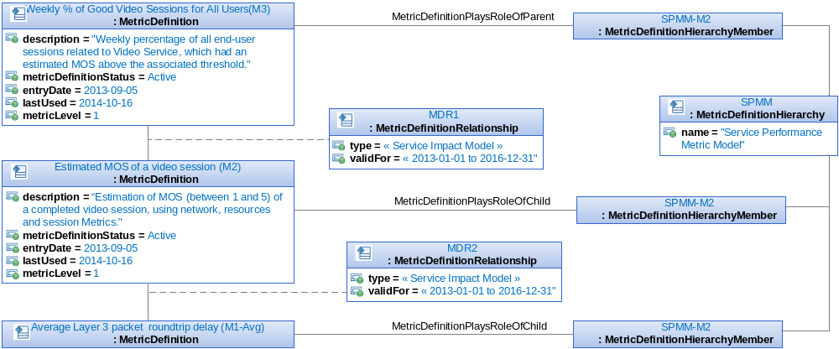
Figure Me.04-Ex.01 – MetricDefinitionHierarchy
Many different parties can be involved with the definition of a metric. Figure Me.05 – Metric Definition Involvement shows the part of the model that represents this involvement.
A Party independent of the role they play can be involved or a role played by a party (PartyRole) can be involved.
The involvementType attribute of MetricDefinitionInvolvement specifies the type of involvement, such as the source, user, owner, defining authority of the MetricDefinition.
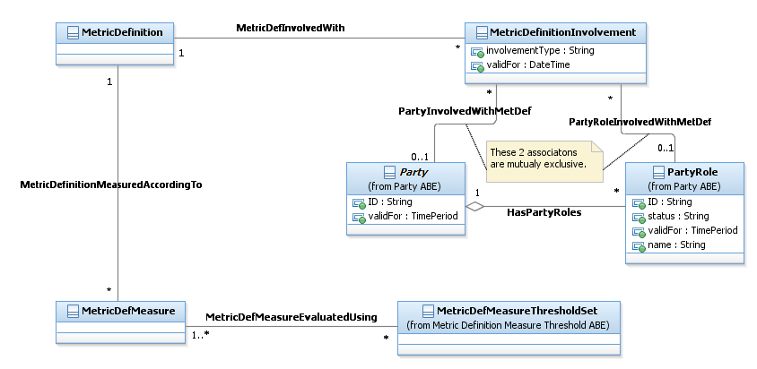
Figure Me.05 – Metric Definition Involvement

An example of an involvement relating a metric (or rather its MetricDefinition) to a Party or PartyRole is given in following Figure.
The involvement here refers to the responsibility of performing the measurement of the M1-Avg metric and reporting the results, presumably via a measurement system with a GUI for network and service administrators.
This data model example would represent the point of view of a network operator which would contract a third-party company as a supplier of this measurement and reporting service.
Note that the validFor attributes are different in each instance, since they describe the validity period of each object: validity of the metric involvement, validity of the entity modeled as a Party, and validity of the entity PartyRole as a supplier (which may or may not be the same as the validity of the metric involvement).

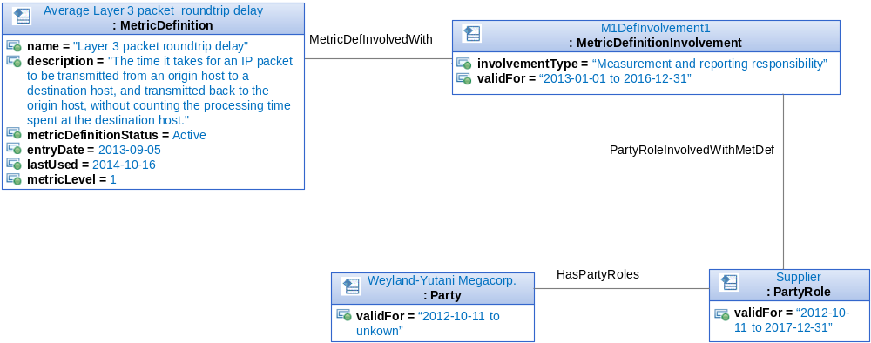
Figure Me.05-Ex.01 – MetricDefinitionInvolvement

There is often the need to add additional attributes to the definition of a metric or to add attributes that are specific to an instance of a metric.
Figure Me.06 – Metric Definition Using Characteristics shows how the Characteristic model can be used to support this requirement. More information on Characteristics can be found in the Root Business Entities guide book.

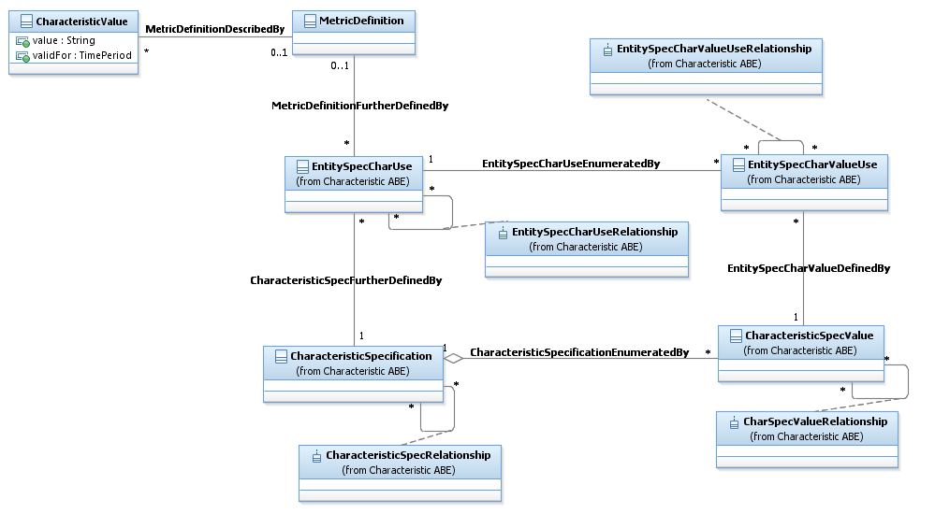
Figure Me.06 – Metric Definition Using Characteristics

Figure Me.07a - Metric Threshold Definition - Derived Associations shows an overview of how threshold are specified for a MetricDefMeasure.
A MetricDefMeasure specifies a measure of a specific aspect of an entity, such as lost packets or dealer sales target achievement, defined for a MetricDefinition that may trigger consequence (s) (MetricDefMeasureConsequence) if a threshold (MetricDefMeasureThreshold) is crossed.
A MetricDefMeasureThresholdSet provides a way to group a set of one or more MetricDefMeasureThresholdRules specifying the condition to evaluate for applying consequences.
The thresholdType specifies the type of MetricDefMeasureThresholdRule contained in the MetricDefMeasureThresholdSet.
The value is “LogicDefinition” if the MetricDefMeasureThresholdSet contains only MetricThresholdRuleDefinition instances and “PreDefined” if it contains only PreDefinedMetricThresholdRule instances.
A MetricDefMeasureThresholdSet is used to evaluate one or more MetricDefMesures.
Threshold rules (MetricDefMeasureThresholdRule) may differ in the condition that they apply, a raise condition or a clear condition, and in the severity of the threshold crossing.
A MetricDefMeasureConsequence defines the action (prescribed action or notification) taken when a MetricDefMeasureThresholdRule is crossed and might depend on MetricDefMeasureThresholdRule applied or not for the previous MetricMeasure.
When a MetricDefMeasureConsequence is applied (track as a MetricMeasureConsequence) this is the result of a single rule (MetricDefMeasureThresholdRule) being crossed.
Different consequences (MetricDefMeasureConsequence) can be defined for different severities.
The repeatAction attribute on MetricDefMeasureConsequence is an indicator used to specify that a consequence
- should cease being applied if a value is in the same range as the previous value
- or continue being applied if a value is in the same range as the previous value.
If the repeatApplication is True, the consequence is always applied as soon as the MetricMeasure value is in the range of values and if the repeatApplication is False, the consequence is applied only if the previous MetricMeasure value wasn’t in the same range.
Nota:
- The two associations pre-fixed by a slash correspond to derived associations.
- A derived association represents synthetically several associations. See example with the next figure Me – 07b.
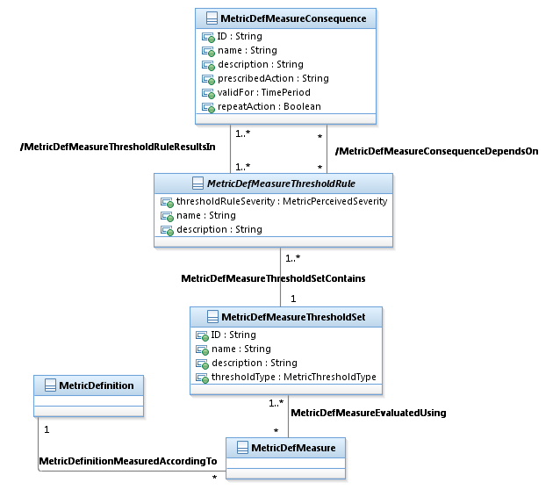
Figure Me.07a - Metric Threshold Definition - Derived Associations

Figure Me.07b - Metric Definition Threshold Associations shows the detailed associations for MetricDefMeasureThresholdRule.
The MetricDefMeasureThreshConsDependency specifies the type of dependency that may exist between MetricDefMeasureConsequence and MetricDefMeasureThresholdRule. For example, "the consequence is triggered only if the rule has been applied previously", or "if the rule has already been applied then do not trigger the consequence".
The two associations MetricDefMeasureConsequenceDependentUpon, MetricDefMeasureThresholdRuleDefines and the entity MetricDefMeasureThreshConsDependency are summarized through the derived association “/MetricDefMeasureConsequenceDependsOn” on the Figure Me.07a - Metric Threshold Definition - Derived Associations.
The MetricDefMeasureThresholdConsequence specifies the sequence of application when several MetricDefMeasureConsequence have to be applied for a specific MetricDefMeasureThresholdRule.
The two associations MetricDefMeasureThresholdRuleResultsIn, MetricDefMeasureConsequenceDeterminedBy and the entity MetricDefMeasureThresholdConsequence are summarized through the derived association “/MetricDefMeasureThresholdRuleResultsIn” on the Figure Me.07a - Metric Threshold Definition - Derived Associations.
Note: A derived association enables more synthetic views and is less accurate than the real detailed associations but has not to be implemented.
The MetricDefMeasureThresholdRelationship enables specifying any kind of relationships between MetricDefMeasureThresholdRule such as depends on, follows, and so forth.

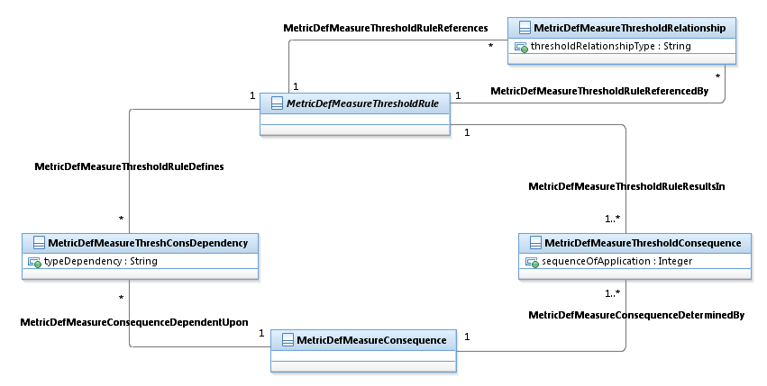
Figure Me.07b - Metric Definition Threshold Associations

Figure Me.07c - Metric Threshold Definition shows the detailed view of how threshold are specified for a MetricDefMeasure.
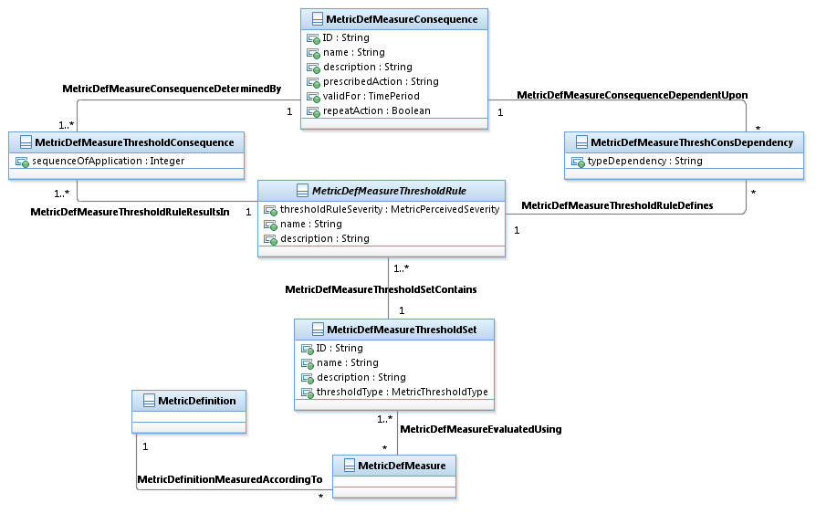
Figure Me.07c – Metric Indicator – Threshold
Figure Me.08 – Metric Definition Measure Threshold Rule shows the different types of threshold rules that might be defined.
A MetricDefMeasureThresholdRule is a rule that defines the condition (raise or clear) to achieve to apply consequences when a threshold (MetricDefMeasureThreshold) is crossed or ceased to be crossed. It may behave in one of two different ways:

- Either it provides attributes for various kinds of threshold logic definition (MetricThresholdRuleDefinition),
- or it is defined by a derivation algorithm that represents a predefined logic that can be executed with parameters (PreDefinedMetricThresholdRule).

A MetricThresholdRuleDefinition specifies the threshold range of values (lower and upper conformance target) with comparators (lower and upper comparator), tolerances and, grace periods, and a comparator.
Each comparator is an operator that specifies whether MetricDefMeasureThresholdSet is crossed when it is above or below a conformance target. For example, a threshold may specify that when average lost packets indicator exceeds a value of 2000 and is under 3000, then the threshold is crossed.

A PreDefinedMetricThresholdRule is a "blackbox" logic and is defined by a named predefined logic that can be executed with parameters. Therefore, the PreDefinedMetricThresholdRule entity will hold the rule name, and the PreDefinedMetricThresholdRuleParam will define the parameters that are required for executing the PreDefinedMetricThresholdRule. As these parameters are often indicator specifications, they can be associated to the MetricDefMeasure entity.

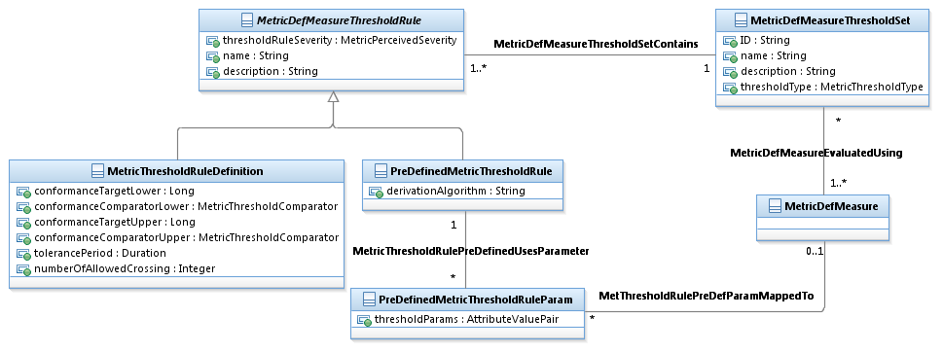
Figure Me.08 – Metric Definition Measure Threshold Rule

The following examples illustrates the use of MetricDefMeasureThresholdSet, MetricDefMeasureThresholdSet and MetricDefMeasureConsequence.

A Metric is defined to evaluate the “Average Layer 3 packet roundtrip delay in millisecond”
- 5 value ranges (thresholds) in millisecond are defined for that Metric
  - [0;100[ Good
  - [100;250[ Acceptable
  - [250;1000[ Bad
  - [1000;+[ Very Bad
  - nil value Not measurable
(may be due to problems such as disconnect or due to sensor failure)

- for each value range one or more Consequences to trigger might be defined:
  - [0;100[ Green GUI
  - [100;250[ Green GUI
  - [250;1000[ Light Orange GUI & raise a Warning notification
  - [1000;+[ Dark Orange GUI & raise a Major notification
  - nil value Red GUI & trigger the diagnose of “not measurable”
- Some consequences are defined according to the previous measure’s value range
  - no longer [0;100[ and whatever the new value is notify degradation
  - no longer [1000;+[ and new value [0;250[ notify end of Major trouble

Rk: To have more simple diagrams the entities used to detail the relationships are not represented (MetricDefMeasureThreshConsDependency and MetricDefMeasureThresholdConsequence) in the illustrations.

Here for any measure in the range of [0;100[ the consequence “update GUI to green” is triggered.
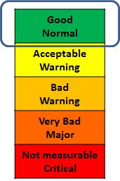
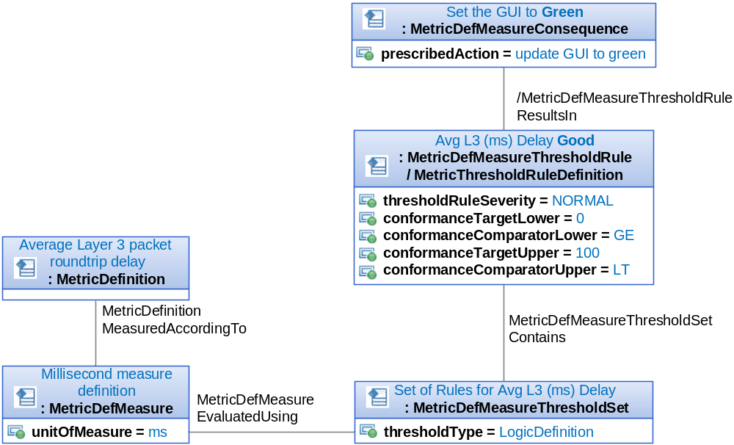
Figure Me.07-08-Ex.01 – Simple consequence

According to the previous measure (MetricMeasure) compared to the new measure, a consequence might be triggered.

In this example, if the previous measure was between 0 to 100 and the new measure is out of this range of values (specified by the “DependsOnPrevious” association), then a notification is sent to alert about the degradation.
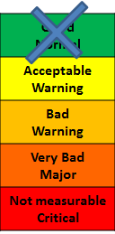

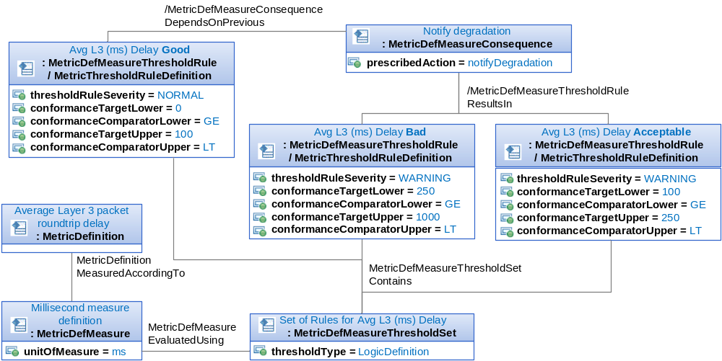
Figure Me.07-08-Ex.02 – Constraints on consequences

The same rule may trigger several consequences.
Here for any measure in the range of [250;1000[ two consequences are triggered (Light Orange GUI & raise a Warning notification).
And the same consequence might be re-used.
Here for any measure in the range of [250;1000[ or [100;100[ a Warning is notified.
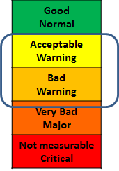

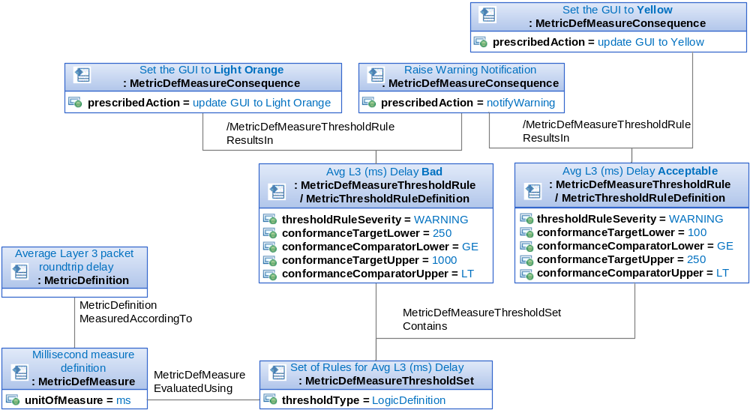
Figure Me.07-08-Ex.03 – Several consequences and re-use

In this example, we assume that the captureFrequency defined by the MetricDefMeasure is 10 seconds. So, we will evaluate 7 measures during 60 seconds.

The tolerancePeriod is 60 seconds and the numberOfAllowedCrossing is 1.
Then if we evaluate the following measures 50, 500, 2000, 100, 60, 80, 90
no consequence will be initiated.

But if the measures are the following 50, 500, 2000, 100, 60, 80, 1500 then the two consequences will be initiated.
Note: When no value is specified for a conformanceTarget Upper or Lower this means it is boundless.

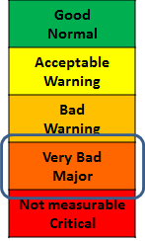
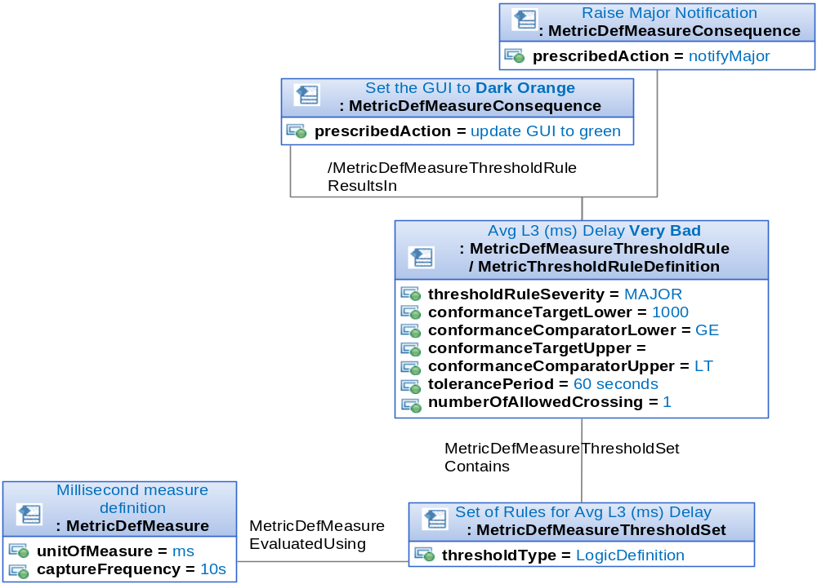
Figure Me.07-08-Ex.04 – MetricThresholdRuleDef tolerancePeriod, toleranceNumber

Sometimes, the measure is impossible.
In this case, specific actions (consequences) might be triggered.
Here, adding to the fact that the GUI is changed to Red, a diagnose action is triggered identifying the root cause of the trouble.

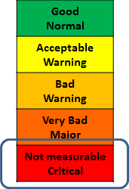
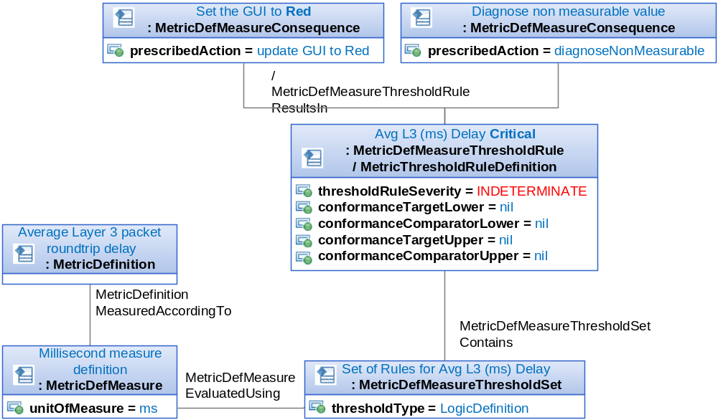
Figure Me.07-08-Ex.05 – Specific consequences for non-measurable

Other example for a Metric defined to evaluate the “Average Layer 3 packet roundtrip delay in millisecond”
Exceptions (thresholds) in millisecond are defined for that Metric
- Normal, 0 =< value < 500, no need to be modeled, as only exceptions are modeled
- Major, Crosses: 500 =< value, Clear exception: value < 460
- nil value Not measurable
(may be due to problems such as disconnect or due to sensor failure)
For each event of a threshold crossing/ceased to cross one or more Consequences to trigger might be defined:
- Raise an Alarm of the specific severity
- Clear an Alarm of the specific severity
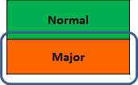
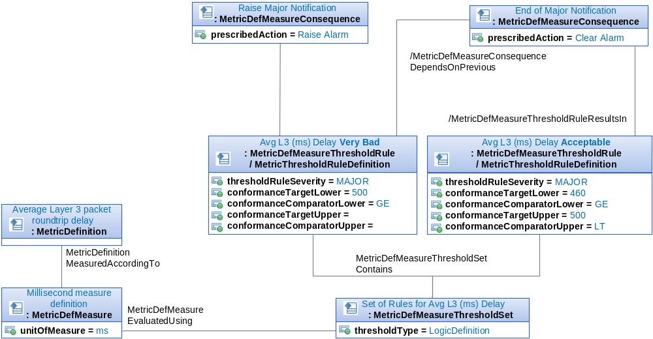
Figure Me.07-08-Ex.06 – Example 2 of rules for a MetricDefMeasure
An alternative solution for this case would be to use the MetricDefMeasureThresholdRelationship as it is represented hereafter.

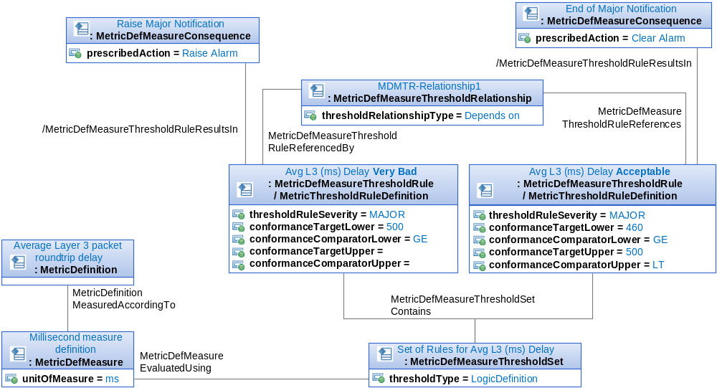
Figure Me.07-08-Ex.07 – Example 2 of rules for a MetricDefMeasure- Alternative Solution

Different kinds of consequences may be applied as a consequence of threshold. Figure Me.09 – Metric Measure Notification definition shows how to describe notification consequences.

A MetricDefMeasureConsequence either results in a prescribed action (prescribedAction) or one or more ConsequenceMetricNotificationSpecs.

If a MetricMeasureConsequence is triggered by a MetricMeasure (through a MetricMeasureThresholfRule) according to a MetricDefMeasureConsequence and the MetricDefMeasureConsequence results in ConsequenceMetricNotificationSpecs, then a ConsequenceMetricNotification is created for each of them.
A ConsequenceMetricNotification is a type of ConsequenceMetricNotification, which in turn is a type of Notification.
A ConsequenceMetricNotification is described by a ConsequenceMetricNotificationSpec.

Note: To be consistent with the pattern Specification used for ConsequenceMetricNotificationSpec / ConsequenceMetricNotification, a NotificationSpecification should exist in the Business Interaction ABE. This concept would specify the content pattern for each corresponding notification.

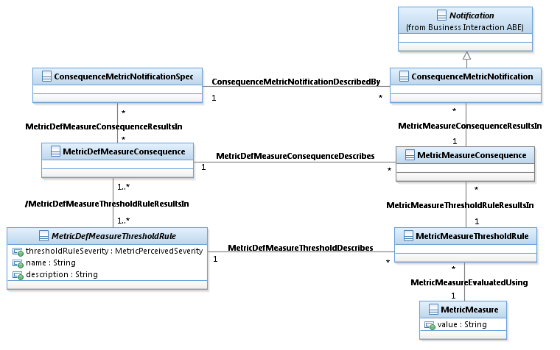
Figure Me.09 – Metric Measure Notification definition

Figure Me.10 – Metric Measure Definition Groups shows how MetricDefMeasures and MetricMeasures may be grouped when needed.

A MetricDefMeasureGroup is a set of MetricDefMeasures, usually reported in the same message by the equipment or the EMS.
A MetricMeasureGroup is a set of MetricMeasures, usually reported in the same message by the equipment or the EMS.

For example, a server will typically report CPU related metrics in a single message. These metrics may include: Maximum CPU usage, Average CPU usage, System CPU usage and User CPU usage.
Mobile RAN may group related metrics by functional aspects in a technology context such as: LTE Intra-frequency handovers, UMTS Radio Access or NodeB Utilization.
Standard protocols like MTOSI or 3GPP will pack the Metric Group in a single message either the same line in a CSV file or within XML tags when the data format is XML.

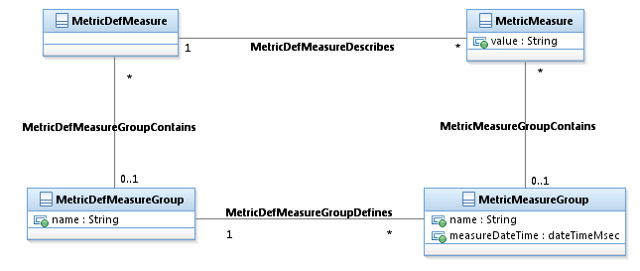
Figure Me.10 – Metric Measure Definition Groups

Figure Me.11 – Metric Measurement Job shows how to define jobs to measure MetricDefMeasures and MetricDefMeasureGroups.

A MetricManagementJob is a management activity that may consist of several steps but is performed as a single logical unit in a Metric context.
It can be a one-time activity or a regular one. In the latter case, a schedule definition is attached to it.

A MetricMeasurementJob always defines a scope of monitored objects using the MonitoredMetricObjectCirterion.
A MetricDefMeasure as well as a MetricDefMeasureGroup may be measured by one or more MetricMeasurementJob.

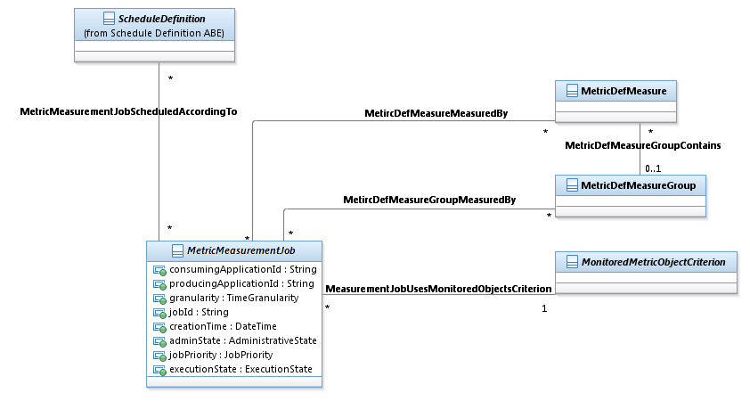
Figure Me.11 – Metric Measurement Job

Figure Me.12 – Monitored Metric Object Cirterion shows the different types of MonitoredMetricObjectCirterion.

A MonitoredMetricObjectCirterion defines the scope of monitored objects for which a MeasurementJob is executed.
The scope is either defined:
• by a filter on a Class (sub-class MonitoredMetricClassCirterion)
• or by a list of instances (sub-class MonitoredMetricInstanceCirterion).

A MonitoredMetricClassCirterion is a type of MonitoredMetricObjectCirterion.
It defines the scope of monitored objects for which a MeasurementJob is executed.by a filter on a class through the relationship with RootEntityType.

A MonitoredMetricInstanceCirterion is a type of MonitoredMetricObjectCirterion.
It defines the scope of monitored objects for which a MeasurementJob is executed by a list of instances through the relationship with one or several RootEntity instances.

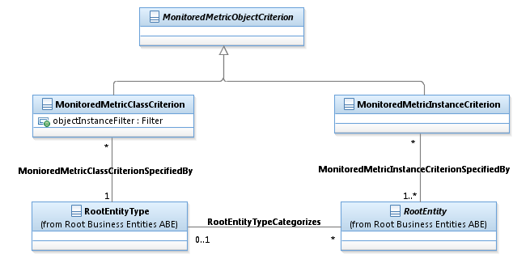
Figure Me.12 – Monitored Metric Object Criterion

Figure Me.13 – Metric Threshold Job and MetricDefMeasureThresholdSet shows the different types of MetricMeasurementJob.

A MetricMeasurementJob may be
- either a job for evaluating thresholds defined over MetricDefMeasure (MetricMeasurementThresholdJob),
- a job for producing MetricMesures according to a MetricDefMeasure (MetricMeasurementProductionJob),
- a job for collecting MetricMeasures produced by another job (MetricMeasurementCollectionJob),
- or a job for collecting MetricMeasures produced by another job to make available MetricMeasures for subscribers. (AdhocMetricCollection)

A MetricMeasurementThresholdJob evaluates one MetricDefMeasureThresholdSet.

A MetricMeasurementJob defines a scope of monitored objects using the MonitoredMetricObjectCriterion.
A MetricMeasurementJob also defines a scope of monitored objects using the MonitoredMetricClassCriterion.

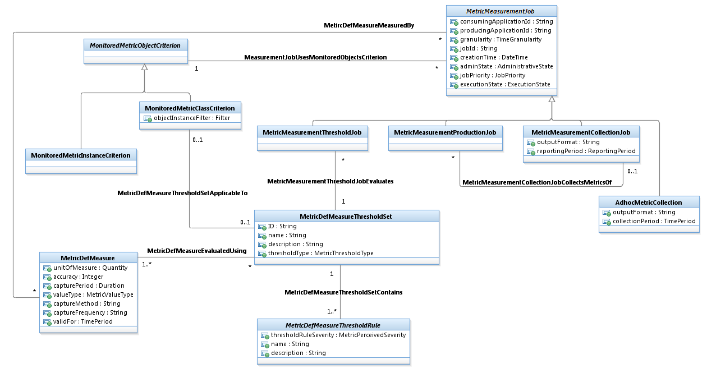
Figure Me.13 – Metric Threshold Job and MetricDefMeasureThresholdSet

A MetricDefMeasure, MetricDefMeasureThresholdRule or even MetricDefMeasureConsequence might applicable only during certain periods.
In this case, the MetricDefMeasureApplicability is used to specify in detail each applicable period.
The MetricDefMeasureApplicability represents the time of day or days during which a MetricDefMeasure, MetricDefMeasureThresholdRule or even MetricDefMeasureConsequence are measurable or not.
The applicableCode attribute Indicates whether an instance represents applicability or un-applicability.
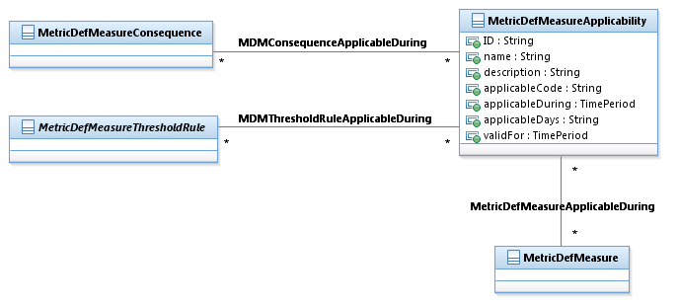
Figure Me.14 - Metric Applicability

The Figure Me.15 - Metric Measure Definition Expression shows how the relationships with MetricDefMeasures might be refined.
For example, a MetricDefMeasureExpression might enable specifying a specific period of applicability or un-applicability (MetricDefMeasureApplicability) for MetricDefMeasureConsequence and / or MetricDefMeasureDefMeasureThresholdRule in the context of a specific MetricDefMeasure.
This capability is useful as MetricDefMeasureConsequence and MetricDefMeasureDefMeasureThresholdRule are reusable by several MetricDefMeasure.
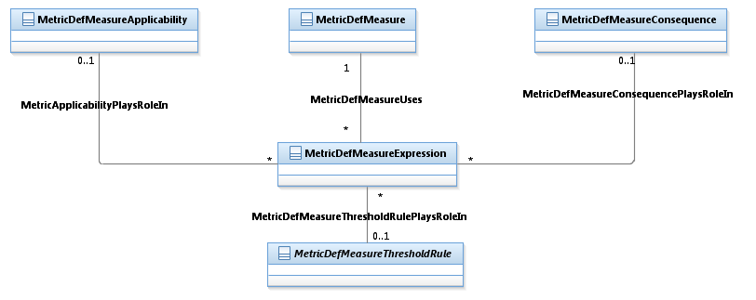
Figure Me.15 - Metric Measure Definition Expression

Metric ABE
Once metrics are defined the values associated with them can be captured. Figure Me.21 – Metric shows the MetricMeasure entity and its directly related entities.
The MetricMeasure might be collected for 0..1 RootEntity because some entities may be explicitly related to a MetricMeasure, such as those entities currently in the Performance, including Service and Resource, and SLA entities, including ProductOffering and ServiceSpecification. These explicit associations represent a more detailed association than the more general association to RootEntity.
This diagram uses RootEntity as an abstract concept showing how any entity can be associated to MetricMeasure.
Since RootEntity is also a real class in the SID model and is the base class of several ABEs (Resource, ResourceSpec, Service, Service Spec and Policy) this diagram also includes examples on how to model Metrics that measure entities which are not subclasses of RootEntity in the SID model.
For example, suppose there is a need to collect a metric for the Service instance of RootEntityType. The first step is to select one of the MetricDefinition(s) for it, then the MetricDefMeasure to use, then the MetricDefinitionDeterminationMethod.
The MetricMeasure is associated to the method and to RootEntity (not RootEntityType) that represents for example the instance of Service for which the MetricMeasure is being collected.
There are indirect associations (i.e. derived) from the MetricMeasure to the MetricDefMeasure via the association to MetricDefinitionDeterminationMethod and from MetricMeasure to MetricDefinition via its association to MetricDefMeasure.

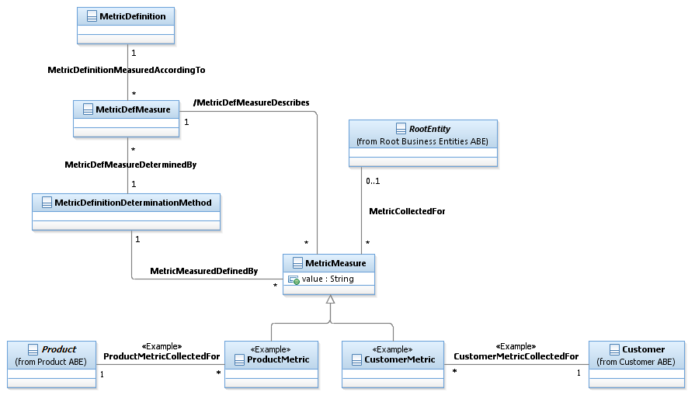
Figure Me.16 –Basic MetricMeasureEntities

A MetricDefMeasure specifies a measure of a specific aspect of an entity, such as lost packets or dealer sales target achievement, defined for a MetricDefinition that may trigger consequence (s) (MetricDefMeasureConsequence) if a threshold (MetricDefMeasureThreshold) is crossed.
A MetricMeasure is a numerical value or text determined for a MetricDefMeasure that may be collected for a RootEntity, such as a connection or a dealer.
A MetricDefMeasureThresholdSet provides a way to group a set of one or more MetricDefMeasureThresholdRules specifying the condition to evaluate for applying consequences.
A MetricDefMeasureThresholdSet is used to evaluate one or more MetricDefMesures.
Threshold rules (MetricDefMeasureThresholdRule) may differ in the condition that they apply, a raise condition or a clear condition, and in the severity of the threshold crossing.
A MetricDefMeasureConsequence defines the action taken when a MetricDefMeasureThresholdRule is crossed.
When a MetricDefMeasureConsequence is applied (tracked as a MetricMeasureConsequence) this is the result of a single rule (MetricDefMeasureThresholdRule) being crossed.
Different consequences (MetricDefMeasureConsequence) can be defined for different severities.
A MetricMeasureThresholdRule specifies the MetricDefMeasureThresholdRule whose threshold has been crossed by a MetricMeasure.
It triggers one or more MetricMeasureConsequences. For example, the prescribed action by a consequence might be to monitor the MetricMeasure more closely or to notify a specific person or the lost packets MetricMeasure with a value of 2500 would be associated with the threshold of no more than 2000 lost packets through a MetricMeasureThresholdRule.

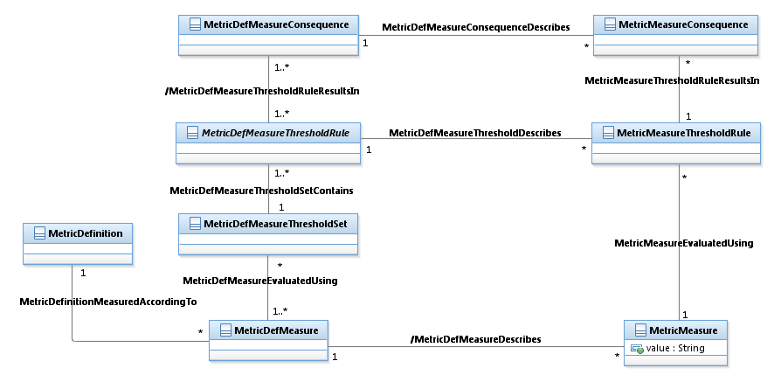
Figure Me.17 – Metric Threshold

The following examples illustrates how the consequences are triggered according to the MetricDefMeasureThrsesholdRule applicable.
Here a MetricMeasure has been measured with a value of 50.
As 50 is between 0 and 100, the consequence resulting from the Avg L3 (ms) Delay Good MetricDefMeasureThresholdRule is triggered.

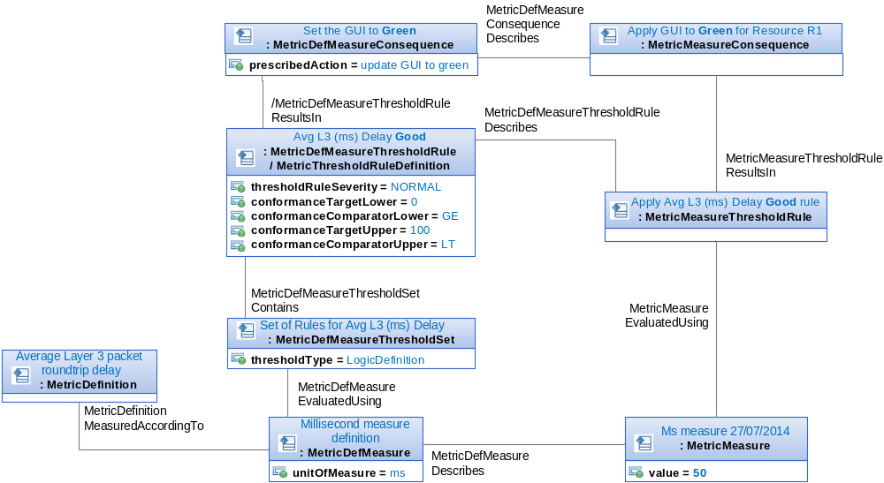
Figure Me.17-Ex.01 – MetricMeasure and triggered consequence

In this example, a second measure with a value of 500 has been measured.
As 500 is between 250 and 1000, the consequence resulting from Avg L3 (ms) Delay Bad MetricDefMeasureThresholdRule is triggered according to the fact that the previous MetricDefMeasureThresholdRule applied was the Avg L3 (ms) Delay Good.
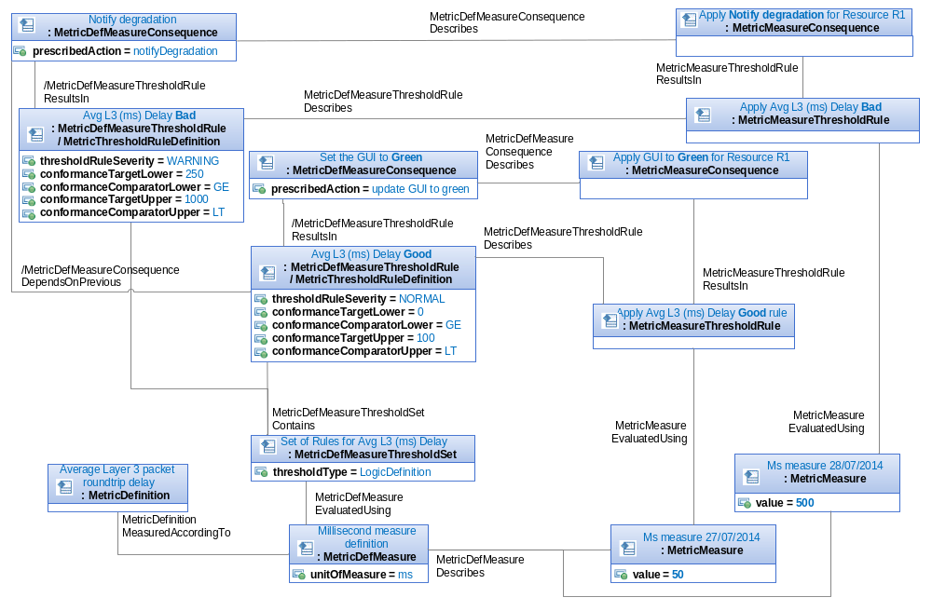
Figure Me.17-Ex.02 –Consequence depends on previous rule
In this example, a third measure with a value of 1500 has been measured.
As 1500 is upper than1000, the two consequences resulting from Avg L3 (ms) Delay Very Bad MetricDefMeasureThresholdRule are triggered.

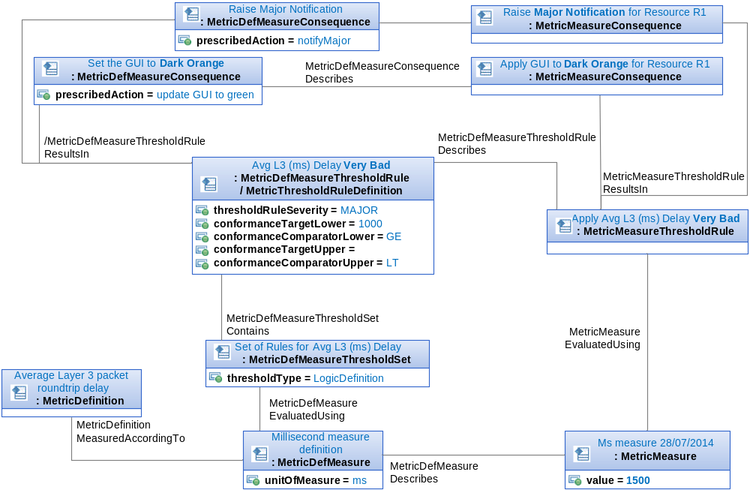
Figure Me.17-Ex.03 – Several consequences triggered for a MetricMeasure

This example is a second example for applying the depends that can exist between MetricMeasureConsequence and MetricDefMeasureThresholdRule.
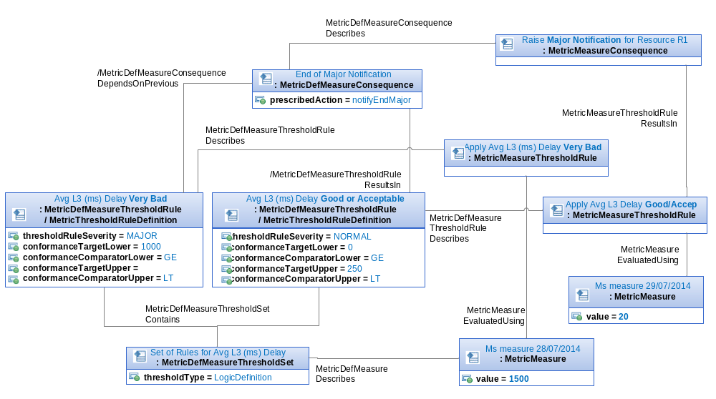
Figure Me.17-Ex.04 – Consequence depends on previous rule

A MetricMeasurementJob might be triggered by the schedule or might be triggered by a request from a PartyRole.
In both cases, a MetricMeasurementObservation tracks each measurement (i.e. execution of a MetricMeasurementJob).
A MetricMeasurementObservation represents the contextual information of a measurement such as the observation period, the MetricMeasurementJob used, the requester of the observation (PartyRole) and the scope of the observation through the related MonitoredMetricObjectCirterion.
The MonitoredMetricObjectCirterion related to MetricMeasurementObservation has to be equal to or a sub-set of the one related to the concerned MetricMeasurementJob.
A MonitoredMetricObjectCriterion might be re-used by many MetricMeasurementJobs or MetricMeasurementObservations.
A MetricMeasurementObservation also specifies the MetricMeasures resulting from this observation.
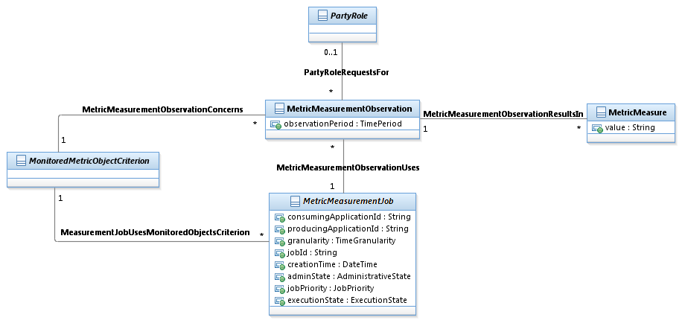
Figure Me.18 – Metric Observation

Best Practices

Generic Best Practices

<<To be supplied.>>

Use Case-Specific Best Practices

Case 1 – TM Forum GB935 Business Metrics

Basic Metric Concepts
The business metrics that have been developed and housed in the Business Metrics Scorecard represent areas of business operation that are important in assessing business performance, customer satisfaction/loyalty and operational efficiency. Any metric managed by the BMS team will be called a business metric. A business metric must:
- Be intelligible to anyone familiar with high-level telecom business concepts; i.e. a business metric does not require specialist or technical knowledge
- Be appropriate to include in a business scorecard, i.e. a set of enterprise-level performance indicators of the business
- Be part of a select minority of all metrics; i.e. it is not likely that all measurable things are business metrics.
According to the US National Institute of Standards and Technology, “a measure is for more concrete or objective attributes and metric for more abstract, higher-level, or somewhat subjective attributes”. A measure is a more general concept than a metric. Any quantity can be measured, but a good business metric also has a clearly understood preferred progression, a numerical directionality which indicates how we’d like to see the metric change as the business improves. Preferred progression can come in many different flavors, like:
• The higher, the better (like revenue)
• The lower, the better (like customer response time)
• The closer to a specific value, the better (like body temperature)
• Can be equal to or lower than a value, but must not exceed (like a speed limit)
• Can be equal to or higher than a specific value, but must not be lower (like bank account balance).
A metric is more likely to be some sort of comparison between two values, often expressed as a ratio, less frequently as a difference. But still, not all metrics need be comparisons. So, for example, one can have a metric which is the number of days it takes to go from bill cycle close to bills issued. However, even this simple count does have directionality – since the shorter this delay, the better.

A metric begins with the thing being measured. The measurand is the “entity quantified by the measure”. Important kinds of measurands in the BMS work include:
- number of subjects, or more specifically:
- number of things (like # bills)
- number of events (like # customer contacts)
- number of people (like # customers)
- monetary value of subjects
- monetary value of things (like $ value of bills)
- monetary value of processes or capabilities (like $ cost of assurance)
- time durations
- time durations for work effort (like # hours for all order processing)
- time durations between events (like # hours between customer requested date and customer committed date).
A benchmark generally suggests that a number or set of numbers is available for the metric that is indicative of either an average or a target for the industry. While the BMS team is responsible for defining business metrics, the Benchmarking team is responsible for running benchmarking studies using these metrics, which generates reports containing benchmark numbers, both average and 80-percentile values, among others.
A dimension is a breakdown scheme for a metric. For example, a metric like “Revenue” can be dimensioned by region, by service, by market segment, etc. or indeed by any combination of these. Ideally, a dimension should not be part of a metric name, since one can instantiate many metrics from one metric by running through all combinations of dimensions – and that just leads to clutter.
Note that Frameworx business metrics are service offering (SO) agnostic, and as such can be dimensioned by any appropriate service. That means that the same metric (F-CE-2a Mean Duration to Fulfill) would be used to study service fulfillment time for residential broadband, mobile services, or IP VPNs. Obviously, the data collected would be quite different. Thus, it is generally not appropriate, for example, to compare a fulfillment metric for mobile service against a fulfillment benchmark for DSL service.

Business Metric Naming
A given metric might be expressed in multiple equivalent ways. For example, one could write “A as a % of B” or “% A of B” or “A/B %”. All this variety can lead to the same metric erroneously entered multiple times in different namings, or else might make it difficult to find a metric given different namings. So, in order to ensure consistency as well as concision in the naming of metrics, a set of naming types was used to standardize metrics, detailed below.
What principles guided these metric name types? A good metric name should provide the gist of the metric without having to resort to looking up further detail. For example, “# hours to fulfill service order” is better than “time to fulfill service order” since we do not need to look up the units. Also, “# hours” is self-explanatory, so we do not need to write “Number of hours”. Also, business objects and their states have been standardized as much as possible; so, we use “bills” instead of “invoices”, for example. Lists of standardize business objects, value drivers, and other expressions are presented later in this chapter.
Some ratios are ratios of the same thing, where some subset based on attribute is in the numerator. This can be written very compactly. For example, “% bills issued electronically” means “% of bills that were issued electronically out of total bills”. A percentage of two different things in the same units can be written as “% opex, of revenue”, where the comma and “of” are used to indicate what the percent is based on. In the most general case, we have two different things in a ratio, like cost of fulfillment per employee. Such ratios are generally not written as percent.
Prose metric names are written in title case. In addition to a Prose Name, a metric also has an “XLS Name”. This is driven by the need to have clear formulas for derived metrics. So, while older formulas exist in Prose Formula form, we have made sure that every formula can also be expressed an XLS Formula using the XLS Names.XLS Names are written in lowercase using the syntax for named ranges in Microsoft Excel, or in other spreadsheet products that adopt the same naming conventions.
To summarize, metric naming in BMS FX13 has been driven by several needs:
- To keep the name as short as possible.
- To keep the name meaningful enough so that we reduce the need to reference the more complete definition in the documentation
- To keep the structure of the names consistent
- To keep the terms in the name consistent (see Business Object Taxonomy for BMS Measurand)
Below are the principle metric naming types used in Fx13:
Type 1: Count – Basic
- Format: # <business-objects>
- Example: # Bills
- Format: # <business-objects><qualification>
- Example: # Bills Issued
- Note: It is important to follow the metric format exactly. Thus, it is “# Bills”, not “# of Bills”, not “# Bills Total”, not “Number of Bills”, etc.

Type 2: Valuation
- Since currency is a count of dollars, it is similar to a count, except that the business object is not countable, but rather a financial concept that can be “evaluated”.
- Format: $ <financial-object>
- Example: $ Revenue
- Note: A native financial concept (like cost or revenue) is easily understood to be evaluable. But if the item being evaluated is not a native financial concept, like the money value of bills issued, we precede the object with “value of”. Thus bills, which can either be counted or evaluated, require the expression “$ Value of Bills” to clearly indicate we mean the dollar value and not the count of bills.

Type 3: Ratio – Simple
- Format: % <business-object><qualification>
- Implication: % <business-object><qualification> / <business-object> Total
- Example: % Activation Failed
- Implication: % Activations Failed / Activations Total
- Note: This is the simplest kind of ratio to express since the same business object is referenced in the numerator and the denominator. Thus a % can be used to denote this type.

Type 4: Ratio – Common Units
- Format: % <business-objects-1> , of <business-objects-2>
- Implication: % <business-object><qualification> / <business-object>
- Example: % Cost of Fulfillment, of Opex
- Implication: % Cost of Fulfillment / Opex
- Note: This is a ratio of two different business objects, but expressed in the same units. Because the units are the same, a % will also be used to denote this type.

Type 5: Ratio – General
- Format: # <business-objects> per <business-object>
- Example: # Minutes per Service Problem Resolution
- Note: This is the most general kind of ratio to express, since the numerator and denominator can be totally difference objects. The “per” is used to denote this type.

Type 6: Ratio – Over One
- Description: There are some BMS ratios that are really not ratios, but needed to be expressed as a numerator over denominator of 1 for historical modeling reasons.

Type 7: Special Name
- Description: Some of the metric names do not follow the above canonical rules. This occurs when a common industry name is preferred. Thus, rather than saying “% Customer Requests Resolved on First Call”, we prefer to use the common industry name “First Call Resolution (FCR)”. Since industry names exist independently of our naming convention, we denote these as Special Names.
- Example: First Call Resolution (FCR).

Type 8: Suffix: Metric-Name-Type – By Dimension
- Description: Generally, a dimension should not be part of a metric definition intrinsically. Rather, the dimensions should be listed out in a separate field, like (Prose or XLS) Dimensions. But we permit this due to historical reasons: some of the metrics already in the Scorecard are pre-dimensioned. But going forward, we advocate that metric dimensions should be extracted from the definition proper, and kept in a Dimension field.
- Format: <metric-name-type> , by <dimension> Type
- Example: # Bills Issued, by Delivery Type
- Note: A dimension phrase is always started with a comma and the word “by” and ends with the word “Type”. Other uses of the word “by” may exist, and these are not dimensioned metrics (like “% Problem Reports Resolved by Due Date”, which does not have the comma before “by”). Also note that a pre-dimensioned metric will have multiple values, distributed by the values of the dimension. So, the above example metric will have values for each of the different Delivery Types, like paper invoice, e-bill, etc.

Type 9: Suffix: Metric-Name-Type – By Dimension Value
- Description: A few metrics are explicitly dimensioned by just one-dimension value. For example, rather than metric by “Service Type”, it is a metric “By Voice Services” only. The construction is similar to the preceding, except there is no “Type” at the end.
- Format: <metric-name-type> , by <dimension-value>
- Example: % Revenue, by Voice Services

Other Patterns
Note that other common patterns also recur within the text of the metric names:
- If a business object’s time between two states is being measured, expressions like “from <state1> to <state2>” appear, as in “# Hours for all Orders, from Ordering to Activation”.
- Generic metric words that can be used everywhere (like Average, Mean or Total) are avoided. The word Mean is actually reserved for the benchmarking reports – as in the mean of a metric given that the sample data has come from many CSPs. Otherwise, without these conventions, we would end up having a “Mean of a Means”, which is a bit unwieldy.
- To distinguish the time for one instance of a business object versus the aggregate time for all instances, the word “All” is used, as in “# Hours for All Orders” (an aggregate) versus “#Hours per Order” (an average or mean).

Business Object Taxonomy
Many of the BMS metrics are about process, and as such, what we are measuring, the measurand, is process, or more broadly speaking, an occurrence. Some measurands are people or stakeholders (# customers, # FTE), while other are artifacts, tangible or informational (# problem reports, # data records). Of course, many are financial in nature ($ cost, $ revenue). A list of business architecture domains will help standardize these measurand categories, which will give us another way to organize, navigate, and analyze metrics. Measurands are substantives, or nouns in our business architecture depictions. Some people call them business objects.
A taxonomy for measurands and other substantives will help limit and control the number of nouns (and ideally states and behaviors) that are used in the metric definitions. For this iteration, our focus has been on the substantives only. We are basing the top-level business architecture domains on the work of the OMG (Object Management Group) BASIG (Business Architecture Special Interest Group) – who have produced a domain model. The top-level measurand domains are:
- Capability
- Stakeholder
- Money
- Artifact (a document, information record, or other business object, like a bill, a payment, a problem report, etc.)
- Occurrence (an initiative, process, behavior or event, that takes place in time)
- Resource (a tangible or intangible material used to deliver products/services to customers).

The list of measurands used in this release of the BMS metrics is as follows:
- Capability
  - assurance
  - repair (a subset of assurance)
  - repair and maintenance (a subset of assurance)
  - billing
  - channel (may overlap Marketing & Sales and CRM)
  - collections (a subset of billing)
  - customer management (referred to as CRM earlier)
  - fulfillment
  - sales (a subset of the Marketing & Sales capability discussed earlier).
- SLA management (a subset of assurance)
  - Stakeholder
  - Customer
Note: The term “customer” is preferred over “user” or “subscriber”
- User
Note: This term is retained for some special uses, such as its use in ARPU, where U stands for User
- Employee (NOC FTE).
- Value
  - account receivables
  - asset
  - billing charge
  - bill
  - capex
  - collectable debt written off
  - cost
  - operating income
  - opex
  - revenue
  - sales.
- Artifact
  - bill
  - billing suspense file
  - data record
  - order
  - problem report
  - service problem
  - settlement report
  - SLA
  - XDR.
- Occurrence
  - activation
  - bill processing fault
  - billing error
  - case of revenue recovery
  - customer call
  - customer contact
  - customer incident
  - customer payment
  - customer request
  - customer transaction
  - failure
  - fulfillment issue
  - installation
  - pricing change
  - service outage
  - SLA violation.
- Resource
    - future infrastructure build
    - revenue system
    - service.
Using this taxonomy, for example, the metric “Average Handle Time” has a measurand of “occurrence.customer_request”, since it represents the time to handle a customer request, which is a kind of business occurrence. The list of measurands will help keep the list of nouns used in metrics to a manageable level.

Resource Performance Management Metrics
Resource Performance Management metrics provides deep insights into the performance of the entire communication network resources and plays important role in assessing operational efficiency, evaluating customer’s experience and conducting operational troubleshooting.
The scope of Metrics for Resource Performance management is very extensive as it includes a wide range of telecommunication domains, such as: Mobile, Fixed, Transmission, Cables, etc. and a large variety of technologies within each one of them.
Equipment vendors may provide dozens to thousands of Metrics per a version of the equipment or per function. The list of provided Metrics per version is usually updated in each new version of the equipment. As a result, it is common for a Resource Performance Management system to be updated few times a year, either to keep up with frequent changes in Metrics or as a consequence of the evolving needs to monitor new equipment added.
In modeling the world of resource performance metrics, a significant distinction to be made is between Metrics that are being measured (also known as Measurements) and Metrics that are being calculated by one of the OSS systems. Typically, a Measurement will be taken by a Network Element or a Probe. It will be then sent to a Management system (usually EMS, sometimes NMS) that may send it to another management system (most typically NMS). Each one of the management systems in the OSS layered architecture may add calculated Metrics to provide additional value and better insight of the network. Such calculated Metrics will be often termed as KPIs (Key Performance Indicators).
When identifying a Resource Performance Metric, the scope of the Metric has to be determined by its dimensions. Network typical dimensions usually include:
- Domain/Main Technology: such as Mobile Core, Mobile RAN, Switching, Transport, etc.
- Specific Technology: This may be a sub-category of the Domain/Main Technology. For example, for Mobile RAN domain, this may include: GSM, UMTS, LTE
- Monitored Network Element/Function (Monitored Object Class level)
- Additional technology specific dimensions
When a Resource Performance Metric is presented, a decision has to be made about the right level of the Metric as reflected in the possible values for the composing dimensions. Currently, different standard organizations defined standard Metrics for the different Domains/Main Technologies; therefore, it makes sense to separate the Metrics at this level. For Specific Technologies and Monitored Network Elements/Functions, these scoping decisions should be probably further examined.
The following example may demonstrate the decisions that have to be taken when classifying a Metric. Let’s look at the “IP Throughput” Metric. We can certainly say the following:
- “IP Throughput” may be used for various network domains, so the option of defining it as a single multi-domain Metric may be raised. Yet, we will probably prefer to differentiate “IP Throughput” of a Transport equipment from the one of a Mobile E-Utran

- A similar question can be raised about differentiating “IP Throughput” among various network elements of the same domain that use IP as their communication protocol.
- For IP communication, it makes sense to differentiate between “Downlink IP Throughput” and “Uplink IP Throughput” so we may actually have another specific dimension in this case, based on the direction of the traffic.
- Interestingly, “IP Throughput” can be calculated for specific “IP Links” or per groups of “IP Links” and not just for a network element object. Moreover, “IP Throughput” may be calculated for additional dimensions that are not even entirely network level such as: “Source Device/Application”, “Target Service/Application” and many more. These should be probably considered as different Metrics.
To continue this example, we may observe that we can look at average throughput, maximum Throughput, Minimum Throughput or a Peak Hour Throughput. Each one of these will be considered as a different Metric as it has a different meaning and may be used at a different context. We can therefore see that different ways of calculating a Metric may generate a different Metrics when the result is used in a different way and has a different meaning.
In general, there are the basic properties that are common to all kinds of Metrics such as: Metric Name, Description, Metric Unit, etc. Some properties are specific to the way that Metrics that are Measurements are being measured. These may include a collection method and additional details on the collection. Calculated Metrics will have a set of properties that define the way a Metric is being calculated, a formula, its components, etc.
A Resource Metric may be collected or calculated per different time granularities with a lot of diversity depending on their usage. For near real-time monitoring or for ongoing maintenance, the time window may start with a multi-second time window up to X Minutes, hourly or daily granularity, with most common 5 minutes or 15 minutes granularities. Metrics that are used for Resource planning may perform aggregative calculations that reach daily, weekly or monthly granularities.
Resource Metrics can be classified by various ways. A useful way was introduced by ITU-T in E.800 document: Quality of telecommunication services: concepts, models, objectives and dependability planning – Terms and definitions related to the quality of telecommunication services. The document is presenting a classification of KPIS to Quality of Service categories.
ITU suggested the following QoS characteristics:
Speed
Performance criterion that describes the time interval that is used to perform the function or the rate at which the function is performed. (The function may or may not be performed with the desired accuracy.)
Accuracy
Performance criterion that describes the degree of correctness with which the function is performed. (The function may or may not be performed with the desired speed.)

Dependability
Performance criterion that describes the degree of certainty (or surety) with which the function is performed regardless of speed or accuracy, but within a given observation interval.
Availability
Availability of an item to be in a state to perform a required function at a given instant of time or at any instant of time within a given time interval, assuming that the external resources, if required, are provided.
Reliability
The probability that an item can perform a required function under stated conditions for a given time interval.
Simplicity
Ease and lack of complexity in the benefit to the user of a function of the service.
3GPP has referred to the ITU adding some specific categories such as “Retainability”, “Mobility”, “Integrity” and “Accessibility” categorization (3GPP TS 21.905: “Vocabulary for 3GPP Specifications”.). Following are some examples for possible QoS classification:
- “Success Rate/Failure Rate” of sessions at different levels of protocol are considered as “Accessibility” Metrics
- “Drop Rates” for Voice/Data/Video are considered as “Retainability” Metrics
- “Latency”/”Delay” of messages are “Integrity” Metrics
- “Mobile Handover Success Rate” is a Mobility Metric (This category is Mobile specific)
- “Availability” (percentage) is an Availability Metric
- “Throughput” is an “Integrity” Metric.
Additional categorizations other than by Quality of Service are of course possible. A distinction should be made between categories that define the Metric from descriptive categories that add details on the Metric.

Characterization of Existing Metrics Models

Overview of OMG SMM
SMM was designed to specify metrics for software artifacts (programs, code, modules). It arose from the Architecture Driven Modernization Task Force of OMG. They are primarily concerned with analysis and characterization of software artifacts (e.g., programs, code libraries, software modules, etc.)
As such it is a static model, with no concept of combining measurements across time.
The assumption is that the system being analyzed is comprised by a set of elements, which are instances of a metamodel. This "target" metamodel defines classes and associations that express the structure of the system being analyzed by a SMM model.
Figure A-1 shows the core concepts of SMM.
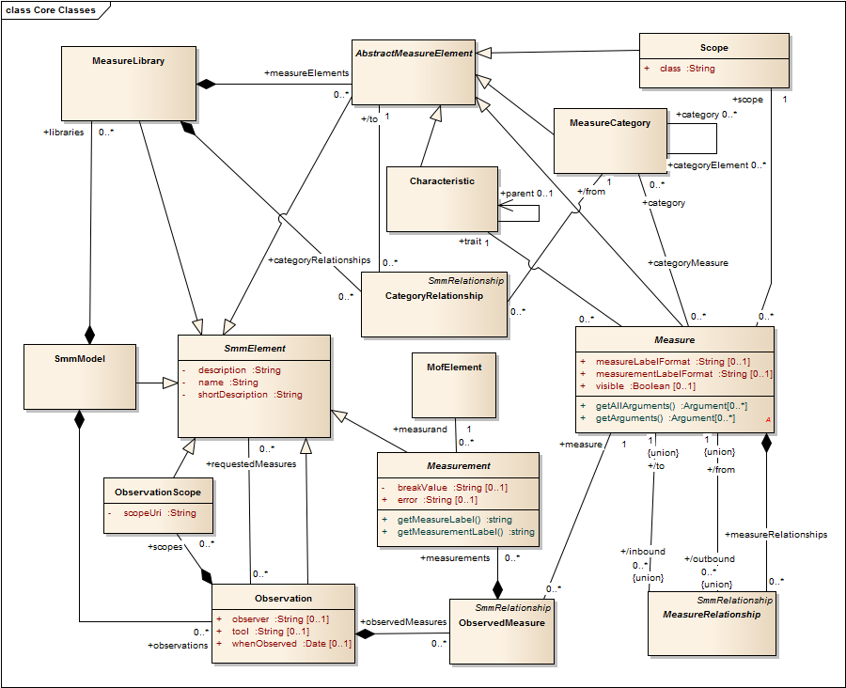
Figure A-1 Core concepts of OMG Structured Metrics Metamodel
A Measure expresses the specification of a calculation that can be evaluated against a set of measurands to create an instance of a Measurement. A Measure has a Scope, which specified a single class of element expressed in the Meta model for the system being analyzed. SMM defines a "measurand" relationship between the Measurement and a MofElement, which points at a particular instance of a class in the target Meta model.
An SMMModel is comprised by a set of observations. The Observation class represents some of the contextual information which may be unique to a measurement, such as date, measurer, and tool used. The ObservationScope class represents the model(s) or sub models that are the subject of the related observation.
The binding of a Measure to a particular Measurement is expressed by the ObservedMeasure relationship class, which ties a Measure to a set of Measurements resulting from an Observation, on a set of related measurands, evaluated at an instance of time.
A Measure has a Scope, which specified a single class of element expressed in the Meta model for the system being analyzed.
A Measure is associated with a single named Characteristic. The Characteristic class represents a property or trait of the members in its scope, a set of MOF Elements, which may be characterized by applying a measure to those members. Characteristic provides for a representation of a hierarchy of measures based upon the abstraction of measured trait. For example, a length characteristic may be the parent of the fileLength and programLength characteristics.
A MeasureCategory has measures and other categories as its elements. A category represents the measures directly associated with an ‘element’ and the measures of each sub-category likewise associated with an ‘element.’ A measure may appear in multiple categories. A category can be a subcategory of other categories indicating only that its measures also are measures of these other categories. This class may be used to represent a family of similar measures that apply to different scopes. The category of a metric may indicate the kind of purpose for which the metric is used.
When a SMM model is run against a set of software artifacts, the measurands are the targets for evaluating the SMM Model to determine the values of a set of Measurements expressed as instances of the SMM metamodel.
A Measure expresses the specification of a calculation that can be evaluated against a set of measurands to create an instance of a Measurement.
MeasureRelationship is an abstract class representing any relationship between two measures.
The MeasureLibrary class represents libraries of measures. A library of measures defines a reference set of measures that can be applied over and over in a way that is independent and decoupled from the models under observation.

The structure of the Measure relationships is expressed in the SMM metamodel, as shown in Figure A-2.
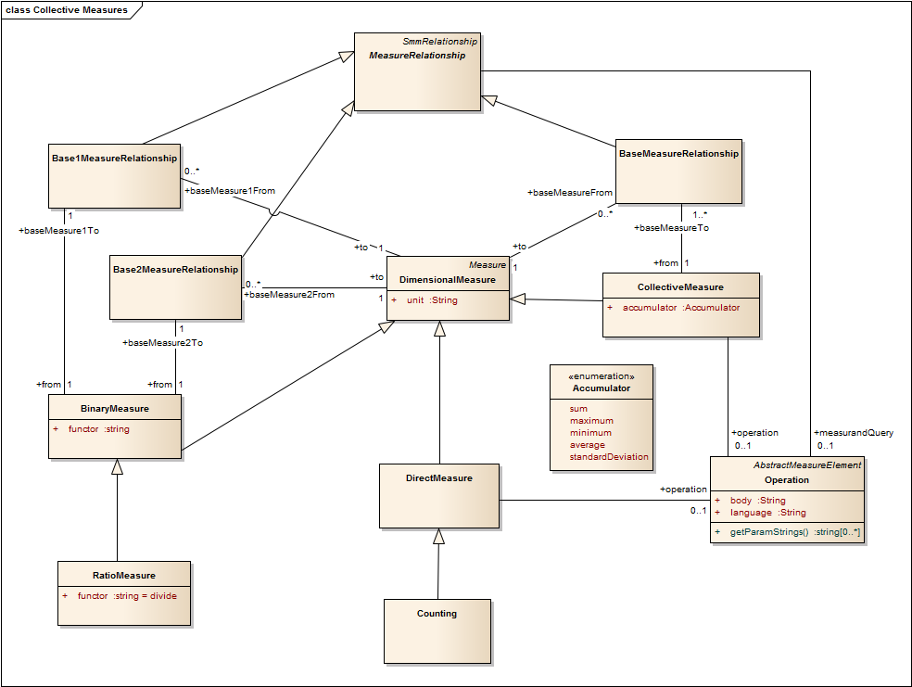
Figure A-3 SMM Measure Relationships
A DimensionalMeasure produces a single numerical value, expressed using a unit of measure. SMM specifies three subclasses of Dimensional Measure:
- A Direct Measure is one which does not involve a composition of subsidiary measures. It applies an operation to the measured entity.
- A Binary Measure is one which evaluates a binary expression (i.e., sum, difference, ratio) involving two subsidiary Measures.
- A Collective Measure represents measures which when applied to a given entity accumulates measurements of entities similarly related to the given entity. For example, it can evaluate an accumulator function across a set of subsidiary Measures taken on measurands which are components of a parent measurand. The accumulator functions specified are sum, maximum, minimum, average, and standard deviation.
The subclasses of MeasureRelationship express the relationships necessary to evaluate Binary and Collective Measures.
The measurandQuery association end of MeasureRelationship specifies a query that is used to determine the measurands that satisfy the relation between two measures.
SMM also defines a parallel structure of Measurement relationships, as shown in Figure A-3.
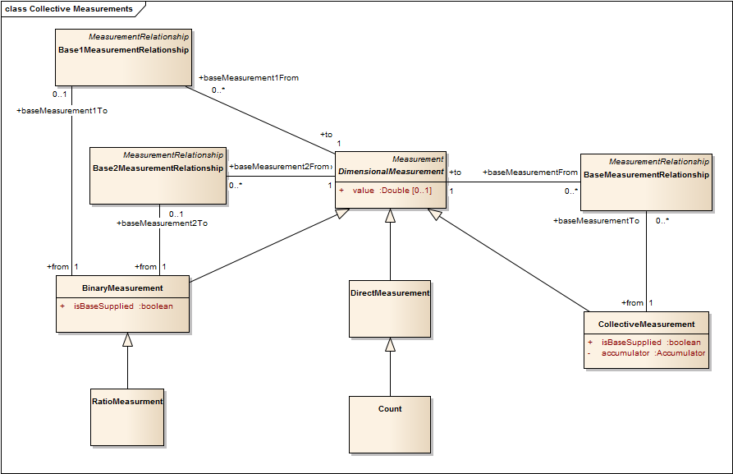
Figure A-3 SMM Measurement Relationships
Overview of OMG SMM

Overview of OSI Systems Management Metric Objects
ISO/IEC 10164-11: 1994 | ITU-T Rec X.739 INFORMATION TECHNOLOGY – OPEN SYSTEMS INTERCONNECTION – SYSTEMS MANAGEMENT: METRIC OBJECTS AND ATTRIBUTES http://www.itu.int/rec/T-REC-X.739-199311-I/en
The OSI-Management Metric Objects specification, unlike the OMG SMM, can work without an underlying metamodel, and it specifies run time objects which perform statistical calculations on a single attribute of an observed managed object over time, using a periodically invoked get operation. The concepts and mechanisms of this specification are applicable to any Cloud Computing environment which has capabilities for getting values of attributes of Cloud Computing Resources. Any REST based protocol could be used by a Metric Object to scan the values of the observed resources.
The underlying targets for the Metric objects are instance of Managed Objects in a running system. OSI-System management has the CMIP protocol which conveys Create, Replace, Update, and Delete operations on an agent process which reflects these management operations in a real world set of Managed Elements, represented as managed objects. CMIP has a simple get operation to get the current value of any attribute of a managed object instance, identified by a unique distinguished name.
Metric Objects specification was designed to define metrics for statistical calculations over time, employing the concept of a scanner.
The data necessary to compute the observed values are extracted from the observed managed objects. The observed values are monitored by sampling at an interval specified by a granularity period.
A Monitor Metric is a scanner that periodically gets the value of an observed attribute of a single Managed Object instance that it points at, with attributes for a managed object instance pointer, the measured attribute name, and a granularity period.
The Metrics objects model assumes that observed attribute being scanned is either a counter (monotonically increasing integer value) or a gauge (value of a varying quantity). There are mechanisms in the metric objects to derive a gauge from an attribute that is a counter (counter difference package), as well as well as to derive a derivative of a gauge from an observed attribute that is a gauge.
There are also optional scanner mechanisms to specify different scheduling and control capabilities, for the times when scanning of the observed attribute are active.
Metric objects can also have a severity indicating gauge-threshold attribute type which is used to trigger notifications for monitoring resources. There can be multiple threshold levels (each with an associated clear threshold) applied to the derived value in a metric object.
Figure A-4 shows an example of a severity indicating gauge model.
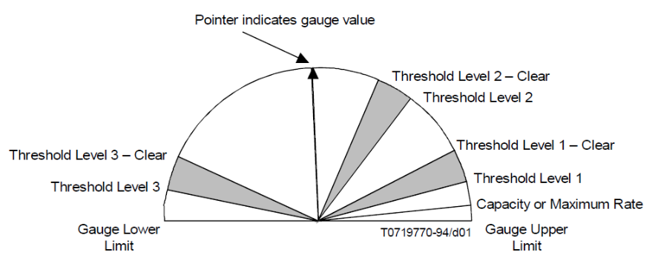
Figure A-4 Severity Indicating Gauge threshold examples
Several subclasses of scanner, each deriving gauge values using various statistic algorithms, are specified
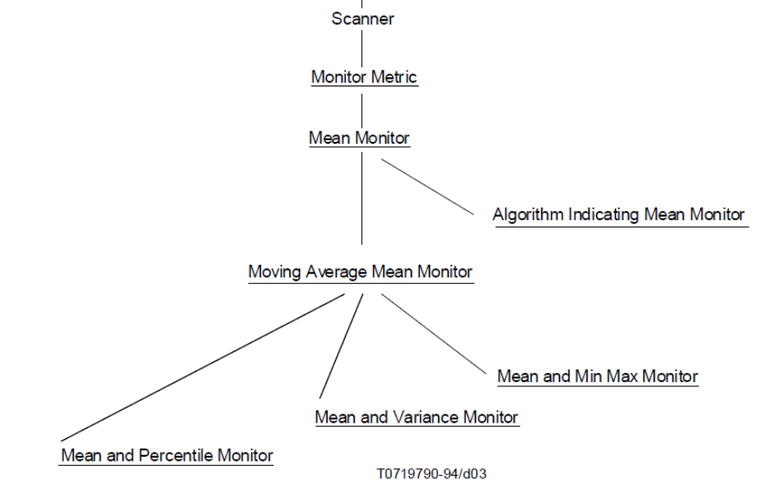
Figure A-5 Inheritance structure of metric objects
The Scanner class has an attribute for the granularity period
The Monitor metric class adds attributes for the observed Managed Object pointer, the name of the observed attribute, and the derived value.
The Mean Monitor class adds attributes for the Moving Time Period (MTP) over which values are scanned, and the derived estimate of the mean taken over the MTP. The algorithm used to specify the mean is not specified.
The Algorithm Indicating Mean Monitor class adds an attribute which specifies the algorithm used to calculate the estimate of the mean.
The Moving average mean monitor class explicitly specifies using an Exponentially Weighted moving average (EWMA) algorithm to calculate the estimate of the means.
The three subclasses of Moving Average Mean Monitor class add EWMA estimates for percentile, variance, and min/max statistics.

Overview of the NIST Cloud Computing Metrics
NIST RATAX-CloudServiceMetricsDescription-DRAFT-V2.3d9 http://collaborate.nist.gov/twiki-cloud-computing/pub/CloudComputing/RATax_CloudMetrics_WAs_Docs/RATAX-CloudServiceMetricsDescription-DRAFT-v2-3d9.pdf
The NIST Metrics model defines terms and concepts which can be represented by Templates which can be used to formally define metrics for cloud computing.
The Model does not assume the availability of an underlying Structured model for the system being measured. As such the binding of the Metrics to real world entities and entity types is informal.
The following terms are defined for the NIST Cloud Computing Metrics model.

Measure (noun)
Value that expresses a qualitative or quantitative assessment of a property of an entity. Is produced as result of a Measurement and is conforming to a Measure Definition.
Note: The definition above is based on the definition of Measure in ISO/IEC 15939:2007. As a result of concerns regarding alignment with other Metric models, which use the term Measure for the abstract definition of the process of measuring, the NIST Metrics WG is considering changing this term to "Measurement Result".
Measure Definition
A definition of the Measure(s) produced in assessing a property of an entity
Measurement
Set of operations having the object of determining a Measure
Note: Based on the definition of Measurement in ISO/IEC 15939:2007. As a result of concerns regarding alignment with other Metric models, the NIST Metrics WG is considering removing this class from the Model, since the semantics are captured by the combination of the Metric and the Measurement Definition concepts.
Metric
A standard of Measurement for a particular Measure Definition, which defines the conditions and the rules for performing the Measurement.
A metric can be understood as a standard set of procedures and rules for generating values for its associated measure definition.
Stakeholders define the scenario of use for a metric. The scenario represents the expectations of an underlying business or operational process (e.g. SLA or Operation) and how the metric will be used to assist such process, what range of values represent acceptable performances of the measured cloud service properties. The scenario also defines the way the metric will be applied – what Cloud resource or service is being measured, under which conditions is the metric evaluation triggered, frequency of the evaluation, etc.
The metrics define the cloud service properties to be measured, their related measure definitions, parameters, formulas and constraints (measurement rules, context conditions).
Typically, a metric is based on a primary measure definition, but may involve other secondary – or underlying – measure definitions, that are subordinate to the primary – i.e. are used by the definition of the primary measure. The measures define the measurement results of the properties observed.
The UML class diagram for the NIST metrics model is shown in Figure A-6
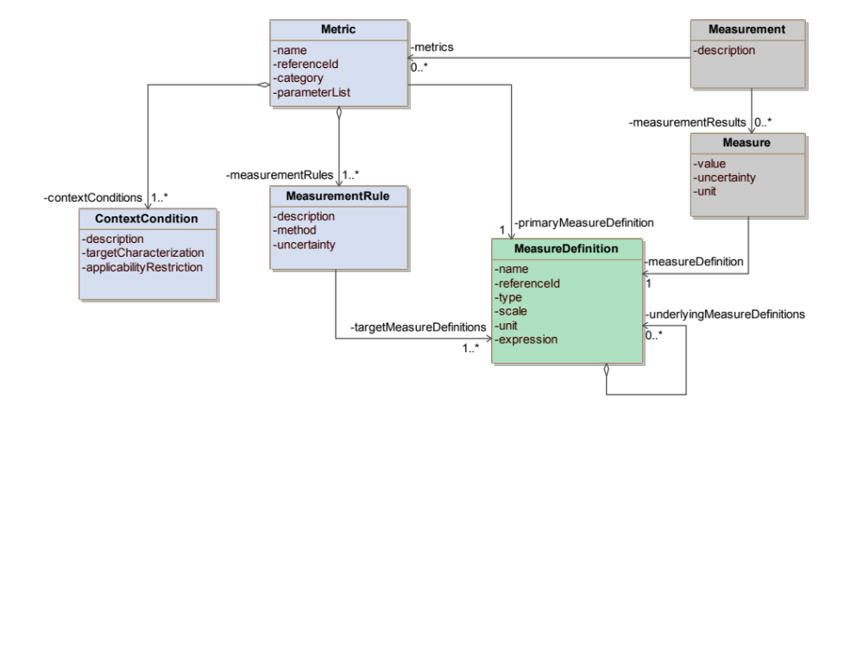
Figure A-6 NIST Metrics Model
In the definitions below the term “element” refers to a UML Class of the model and the term “attribute” refers to a UML Attribute of a UML Class.
ContextCondition
A ContextCondition element is expressing the conditions under which this metric is applicable, in a real environment or context.
The description attribute is a summary of a particular condition of applicability.
The targetCharacterization attribute characterizes the type of Cloud resource(s) to which this metric applies, i.e. the type of resource of which some property can be measured. For example, an availability metric might be exclusively defined for “storage services”, and therefore would not be appropriate to measure the availability of a compute server or of a network.
The applicabilityRestriction attribute is expressing particular constraints to be observed when using the metric. For example, measurement rules in the metric definition may depend on some regulatory environment (e.g. a particular definition of “business time”), which in turn might reduce the scope of applicability to certain countries.
Measure
A Measure element holds the necessary information to understand a value resulting from a measurement of the attribute being observed.
The value attribute represents the result of the observation.
The unit attribute represents the unit of the value at the time of measurement.
The uncertainty attribute represents the uncertainty at the time of measurement.
A Measure element is associated to one MeasureDefinition element. It determines the nature of the Measure element.
Both uncertainty and unit attributes carry run-time values that should be related respectively to the uncertainty budget derived from the measurement rules and the measure definition unit metadata.
MeasureDefinition
A MeasureDefinition element holds the basic information necessary to understand the property to be observed.
The name attribute represents the measure definition.
The referenceId attribute identifies uniquely the measure definition.
The scale attribute gives information on how the measurement value can be interpreted and what sort of operations can be performed on it.
The type attribute represents the kind of the measure.
The unit attribute represents the base unit that will be associated to MeasureDefinition element.
The expression attribute represents the function used to assemble the underlyingMeasureDefinitions that compose the MeasureDefinition.
The underlyingMeasureDefinitions association represents the possibility that a MeasureDefinition element can be composed of other MeasureDefinition elements. This means the MeasureDefinition element expression is using the outcome of other MeasureDefinition elements.
MeasurementRule
A MeasurementRule element is used to further constrain some parts of a Measure element and indicate possible method(s) for measurement. For instance, an “AvailabilityDuringBusinessHour” Metric element could be defined with a scope that constrains some piece of a generic “Availability” Measure element to limit the observation period to defined business hours. Measurement rules are necessary for the measurement
The description attribute is a summary of a particular measurement rule.
The method attribute represents the method of measurement of the targetMeasure.
The uncertainty attribute represents the estimate associated with the targetMeasure. It can be used to help determine the Metric accuracy or precision.
A measurementRule element can influence more than one targetMeasure element (targetMeasureDefinitions association). For instance, a measurement rule could define that all targeted time measures be of unit second.
Metric
A Metric element helps define a cloud service property to be measured, its related measures, parameters, formulas and measurement rules so it can be used in a given context.
The name attribute represents the metric.
The referenceId attribute represents a unique way to identify the metric in a repository.
The category attribute represents the type of the metric (i.e. business, technical, security).
The parameterList attribute lists a set of variable names that can appear at various places under the Metric element – e.g. in some measurement rule or measure definition. The parameterList attribute can be what is needed by an implementer of the Metric element – to use the variables or attribute names inside the list either as parts of a run-time Metric interface, or in a Metric configuration file.
A Metric element is associated to one or more ContextCondition elements (contextConditions association).
A Metric element is associated to one or more MeasurementRule elements (measurementRules association).
A Metric element is associated to one primary MeasureDefinition element (primaryMeasureDefinition association).
Based on feedback from reviewers regarding alignment with other models for Metrics, the NIST Metrics WG is considering changing the name of the Measure class to MeasurementResult, and is removing the Measurement class from the model. The MeasureDefinition class along with the Metrics class adequately captures the semantics of the specification of the calculations used to derive a measurement result. Figure A.7 is a class diagram reflecting current work in the NIST Metrics WG.
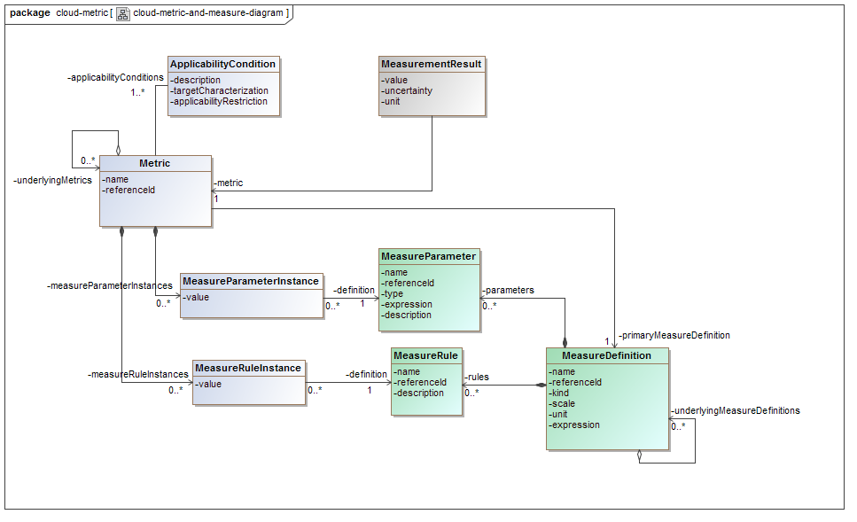
Figure A-7 Refinement of NIST Cloud Metrics model reflecting on-going work

The Model in Figure A.7 is a refinement of the current working draft of the NIST Metrics definition specification. This refined metrics model removes the Measurement class and changes the name of the Measure class in Figure A-6 to MeasurementResult. It represents the relationship that a Metric can have with underlying metrics, and also has classes representing of Measure parameters, Measure parameter instances and measure rule instances.
Figure A-8 is an example of object instances following the refined model in Figure A-7, representing an example of the actual specification of some response time metrics.
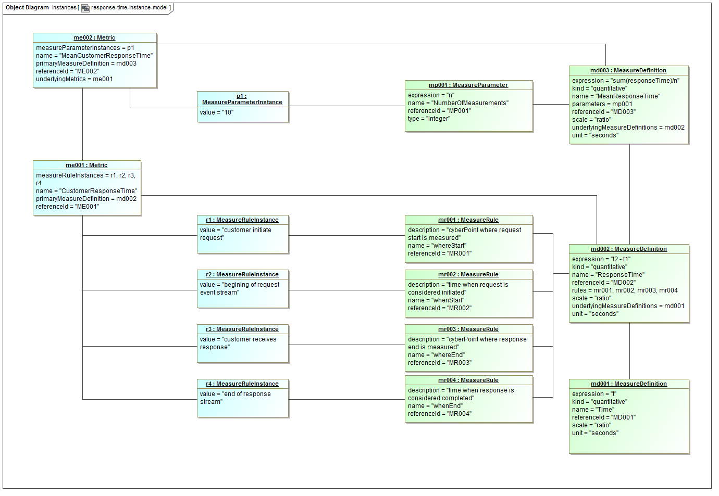
Figure A-8 Example of Use of Refined NIST metrics model to represent response time metrics
The ultimate goal of this work is to specify a set of templates which can be used to define actual Cloud Computing metrics.

Comparison of the Metric Models
This section describes how each of the Models summarized in the preceding sections represent concepts regarding Metrics and their evaluation. They present a high-level view of the differences between these models.
Representing kinds of target for a metric definition
In OMG SMM the Scope class has a pointer to a single named class in the MOF metamodel for the target system.
NIST Metrics Model has an attribute targetCharacterization in ContextCondition class. However, the NIST Metrics model does not assume a model for the target systems is available.
In TM Forum SID Metrics, the relationships between MetricDefinition and RootEntityType and Specification convey the target for a Metric. SMM Scope is not restricted to a single class from the underlying system model.
OSI Systems Management Metric Objects are installed at run time, and there is no restriction to what classes of Managed object can be observed by a Metric Object.
Binding a measurement to a specific target for a single metric evaluation
In OMG SMM the Measurement class has a pointer to a single MofElement instance in the target system.
The NIST model currently only specifies definitions applicable to use in Metric templates. There are no pointer attributes in the Measure class (to be renamed MeasurementResult) to indicate the run time target for the Metric evaluation.
The TM Forum SID Metrics model has an association "MetricCollectedFor" from Metric class to RootEntity class. This can point at an instance of any element defined in the model for the target system.
OSI Systems Management MonitorMetric and its subclasses have a pointer to the observed managed object instance, and its attribute being observed.
Periodic scanning of a target by a Metric
This is the primary purpose for the OSI Systems Management Metric Objects. The MonitorMetric class has a granularity period for subsequent scans (using a get operation) of attribute values of Observed managed objects. The MeanMonitorMetric class has an attribute to specify the moving time period over which the estimate is calculated. The metric objects also have optional attributes to specify scheduling of when the Metric object is enabled to scan.
OMG SMM and TM Forum SID metrics model are static in nature. The assumption is that the Metric will be evaluated for the state of the system at the time of observation. Neither of these models specifies facilities for evaluating statistical quantities over time.
The NIST Metrics model is also a static model. The concept of periodic scanning of resource attributes is not currently supported. There is no way specified to force a measurement to be taken using a periodic test stimulus. The examples assume measurements will be taken upon natural stimuli (i.e., not driven by a test driver). However, the group is investigating how statistical quantities (such as mean and variance) can be evaluated from a set of measurement results taken on a single target over some time interval (e.g., calculating a mean response time for a target over a time period using all available response time measurements taken for that target over that interval).
Representation of a metric Measurement result
OMG SMM has the Measurement class to represent the result of a measurement.
NIST Metrics model currently has the Measure class to represent the result of a measurement. However, the NIST WG is considering changing the name of this class to MeasurementResult, to avoid confusion.
TM Forum metrics model has the Metric class to represent the result of a measurement.
OSI Systems Management Metric Objects have a derivedValue attribute in the MonitorMetric class which stores the current value associated with the Metric. The subclasses also add attributes for the estimate of the statistical quantity taken over a Moving Time Period.
Representation of a metric Measure Definition
OMG SMM has the Measure class to specify the definition for a measurement.
NIST Metrics Model has the MeasureDefinition class to specify the definition for a measurement.
TM Forum metrics model has the MetricDefinition class to specify the definition for a measurement.
OSI Systems management does not allow arbitrary measurement definitions. The behavior of the Metric objects is restricted to operations over time on observed attributes, and is hard coded into the behavior definitions for the Metric objects.
Representation of composite metric measures definitions and measurement results
The OMG SMM specifies:
- A BinaryMeasure class which evaluates a binary operation (e.g., +, -, /, *) on the values of two other Measures. More complicated combination operations need to be expressed by breaking the calculation into a series of binary operation steps.
- A CollectiveMeasure class which evaluates an accumulation operation (sum, min, max, mean, standard deviation) over a set of entities which are involved in a similar relationship with a scoped class.
- No other forms of calculating composite metrics are specified.
In the NIST Metrics model a primary MeasureDefinition can be composed using underlying MeasureDefinitions and an expression in the primary MeasureDefinition).
In the TM Forum Metrics model, a MetricDefinition can be composed using other MetricDefinitions through the use of MetricDefinitionMethodArgument.
OSI Systems management Metric Objects has no facilities to compose multiple metrics.

Correspondence between OMG SMM, NIST, and TM-Forum Metrics Models
Table A-1 shows a first cut at correspondences between classes in the OMG SMM, the NIST Metrics model and the TM Forum SID Metrics model.
OMG SMM | NIST Metrics Model | TM Forum SID Metrics
Characteristic | MeasureDefinition.kind might represent similar concept | MetricDefinitionMeasure might represent similar concept
MeasureCategory | Can be represented by Metric.category | MetricCategory
Scope (SMM Scope is to a single class from the underlying system model) | Similar semantics to ContextCondition.targetCharacterization. However, the NIST model does not assume a model for the target systems is available. | Similar semantics to the relationships between MetricDefinition and RootEntityType and Specification. Application of a metric is not restricted to a single class in the target model for the system.
Measure | MeasureDefinition | MetricDefinition
DimensionMeasure.unit | MeasureDefinition.unit | MetricDefMeasure.unitOfMeasure
Operation (thru the operator association from DirectMeasure | corresponds roughly to the expression in MeasureDefinition | corresponds roughly to the formula In MetricDefinitionDeterminationMethod
Measurement | Measure (to be renamed MeasurementResult to avoid confusion. Also, the NIST Measurement class is to be deleted because its semantics are adequately captured by Metric and MeasurementDefinition classes) | MetricMeasure
Observation | No direct correspondence. The NIST model does not have pointers to resource instances in its definitions for measurement results. | MetricMeasureObservation
ObservationScope | No correspondence | MonitoredMetricObjectCirterion
CollectiveMeasurement, BinaryMeasurement | corresponds to the fact that a primary MeasureDefinition can be composed using underlying MeasureDefinitions and an expression in the primary MeasureDefinition). | Corresponds to the fact that a MetricDefinition can be composed using other MetricDefinitions through the use of MetricDefinitionMethodArgument.
MofEntity (thru measurand association) | No correspondence. NIST model specifies definitions for templates. There are no pointer attributes in Measure class (to be renamed MeasurementResult). | RootEntity (MetricCollectedFor association)
Table A-1 Correspondences with OMG SMM metamodel

Administrative Appendix
This Appendix provides additional background material about this document.

Document History

Version History
Version Number | Date Modified | Modified by: | Description of changes
1.8 | 30 Sept 2013 | John Reilly | Update with all project member contributions
1.9 | 2 Oct 2013 | John Reilly | Update figures based on work item wrap up web meeting
1.9.1 | 14 Oct 2013 | Alicja Kawecki | Updated cover, header and footer, minor cosmetic fixes
1.16 | 16 Apr 2014 | Cécile Ludwichowski | Adds entities from Performance ABE
1.16.1 | 12 May 2014 | Alicja Kawecki | Updated Notice, minor cosmetic fixes prior to posting
14.5.0 | 14 Oct 2014 | Cécile Ludwichowski | Updated with  - More examples  - More details on jobs and jobs execution  Introduction of Applicability
17.0.0 | 21 Ma 2017 | Cécile Ludwichowski | Remove SID framework figure from the guide book
17.0.1 | 23 Jun 2017 | Alicja Kawecki | Applied rebranding and minor cosmetic edits prior to publication for Fx17
17.0.2 | 16 Nov 2017 | Adrienne Walcott | Minor cosmetic edits prior to publishing
17.5.0 | December 2017 | Cécile Ludwichowski | fix typo xLSFormula (FP-105)
17.5.1 | 15 Dec 2017 | Adrienne Walcott | Formatting/style edits prior to publishing
17.5.2 | 06-Mar-2018 | Adrienne Walcott | Updated to reflect TM Forum Approved Status
19.0.0 | 18-Ma-2019 | Cécile Ludwichowski | Fix error of type for capturePeriod attribute from MetricDefMeasure
19.0.1 | 17-Oct-2019 | Adrienne Walcott | Updated to reflect TM Forum Approved Status

Release History
Release Number | Date Modified | Modified by: | Description of changes
13.5 | 30 Sep 2013 | John Reilly | Update with all project member contributions
14.0 | 16 Apr 2014 | Cécile Ludwichowski | Updated with  - Entities according to Performance ABE  - More details for Metric ABE  - Characterization of existing Metrics Models
14.5.0 | 14 Oct 2014 | Cécile Ludwichowski | Updated with  - More examples  - More details on jobs and jobs execution  - Introduction of Applicability
17.0.0 | 21 Mar 2017 | Cécile Ludwichowski | Remove SID framework figure from the guide book
17.0.1 | 16 Nov 2017 | Adrienne Walcott | Updated to reflect TM Forum Approved Status
17.5.0 | December 2017 | Cécile Ludwichowski | fix typo xLSFormula (FP-105)
17.5.1 | 06-Mar-2018 | Adrienne Walcott | Updated to reflect TM Forum Approved Status
19.0.0 | 18-Mar-2019 | Cécile Ludwichowski | Fix error of type for capturePeriod attribute from MetricDefMeasure
19.0.1 | 17-Oct-2019 | Adrienne Walcott | Updated to reflect TM Forum Approved Status

Company Contact Details

Company | Team Member Representative
Amdocs | Josh Salomon
Alcatel-Lucent | Gerard Damm
Telco Corporation | Yuval Stein
IBM Corporation | Robert Bratulic
TM Forum | Steve Cotton
TM Forum | John Reilly
Infonova | Andreas Polz
Orange | Cecile Ludwichowski
NetCracker | Yaroslav Oratovsky
AMKB Cloud | Cliff Faurer

Acknowledgments
This document was prepared by the members of the TM Forum Information Framework (SID) project metrics work item listed in the Company Contact Details above.

http://www.businessdictionary.com, Copyright©2007-2011 Vijay Luthra and BusinessDictionary.com. ALL RIGHTS RESERVED.
http://office.microsoft.com/en-ca/excel-help/define-and-use-names-in-formulas-HA102749565.aspx#_Toc312073993

